**Thematic NPGs version i . 1  
64 NPC** STATBLOCKS by theme from **CR 0** to **CR 18**

By mrvalor Background maps by mrvalor

Cover art by: Spartan Archer by SignalGuv. Monk by n-pigeon. Kaled Assad by DioMahesa. Halfing Rogue by MaNuEli.

Swashbuckler by Gantes. Dhuum by Hvblrd-1982

Special special thanks to ZevTheWolf for the Infantry Captain template, looking over the stablocks, and in general being an

excellent DM collaborator.

**64 Thematic NPG Templates**

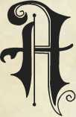s my campaign goes towards 10+, I feel a lack of NPCs geared towards higher levels campaigns. Mind you, legendary NPCs should be legendary, every bit as much so as beholders, ancient dragons, and the like. I made this compilation from a desire to move beyond DGScott’s Versatile NPCs and the hole it helped fill in the existing content. I made this content from a thematic perspective because that’s how I view my world. I see military, monastic, dark arts, urban, seafaring, these different areas that interact with each other. This compilation includes many NPCs, and I'll attempt to categorize and index them in an easily usable way.

**Military**

* Infantry Captain (CR 6) page 15
* Legendary Swordmaster (CR 14) page 15
* Medic (CR 1) page 16
* Novice Soldier (CR 1/2) page 16
* Pikeman (CR 1) page 17
* Sapper (CR 1) page 17
* Savage Infantry (CR 3) page 18

**Monastic**

* Grand Master (CR 17) page 19
* Sacred Fist (CR 8) page 20
* Template Acolyte (CR 1/2) page 21

**Seafaring**

* Deck Boss (CR 6) page 22
* Infamous Pirate Captain (CR 9) page 23
* Legendary Pirate Captain (CR 15) page 24
* Sailor (CR 1/4) page 25
* Pirate (1) page 25
* Pirate Captain (CR 5) page 26
* Privateer (CR 1) page 26
* Veteran Privateer (CR 4) page 27

**Unholy**

* Unholy Archbishop (CR 17) page 28
* Unholy Bishop (CR 15) page 29
* Unholy Curate (CR 2) page 30
* Unholy Deacon (CR 9) page 30

**Urban**

* Beefy Bartender (CR 8) page 31
* Beggar (CR 0) page 32
* Charmer (CR 1/8) page 32
* Diplomat (CR 0) page 32
* Dishonored Veteran (CR 7) page 33
* Gangster (CR 3) page 33
* Hulking Slave (CR 1) page 34
* Knowledgeable Elder (CR 0) page 34
* Legendary Beefy Bartender (CR 15) page 35
* Normal Bartender (CR 0) page 36
* Talented Child Pickpocket (CR 0) page 36
* Town Cryer (CR 0) page 36
* Veteran Scammer (CR 0) page 36
* Wee Con Artist (CR 1/2) page 37

**Wilderness**

* Forest Witch (CR 4) page 38
* Holistic Healer (CR 1/8) page 38
* Outlaw (CR 7) page 39
* Trapper (CR 1/4) page 40
* Veteran Wilderness Guide (CR 6) page 40
* Warrior Shepherd (CR 1/2) page 40
* Wildling (CR 2) page 41
* Witch Doctor (CR 6) page 41

This supplement considers the NPC templates set out in the Monster's Manual, Volo's Guide to Monster's, and 35 Versatile NPCs by /u/DGScott.

Note About Legendary NPCs: As of this time, I have not added legendary resistances and actions to even the higher level NPCs in this document (a handful do have legendary resistances) Appendix B on page 43 outlines my thoughts on Legendary Actions and gives some examples of those from the MM.

**NPCs by Theme**

NPCs listed by theme.

**Arcane**

* Air Sorcerer (CR 12) page 4
* Earth Sorcerer (CR 7) page 4
* Fire Sorcerer (CR 17) page 5
* Water Sorcerer (CR 7) page 5

**Archery**

* Legendary Archer (CR 14) page 6
* Sharpshooter (CR 2) page 6
* Sniper (CR 6) page 7

**Dark Arts**

* Corrupted Humanoid (CR 1/2) page 8
* Demonologist (CR 10) page 8
* Thrall (CR N/A) page 9
* Dire Rat (CR 1) beast, page 9
* Vermin Lord (CR 6) page 9
* Transforming Humanoid (CR 2) page 10

**Espionage**

* Infiltrator (CR 4) page 11
* Informant (CR 1/2) page 11
* Intelligence Agent (CR 13) page 12
* Legendary Operative (CR 17) page 12

**Holy**

* Curate (CR 1) page 13
* Martyr (CR 5) page 13
* Reverand Martyr (CR 14) page 14
* Saint (CR 18) page 14

**Thematic NPCs**

**NPG List by GR**

NPCs challenge rating.

**N/A**

* Thrall (CR N/A), page 9

**CRo**

* Beggar (CR 0), page 32
* Diplomat (CR 0), page 32
* Knowledgeable Elder (CR 0), page 34
* Normal Bartender (CR 0), page 36
* Talented Child Pickpocket (CR 0), page 36
* Town Cryer (CR 0), page 36
* Veteran Scammer (CR 0), page 36

**CRl/8**

* Charmer (CR 1/8), page 32
* Holistic Healer (CR 1/8) page 38

**GR i/4**

* Sailor (CR 1/4), page 25
* Trapper (CR 1/4), page 40

**CRl/2**

* Corrupted Humanoid (CR 1/2) page 8
* Informant (CR 1/2) page 11
* Novice Soldier (CR 1/2) page 16
* Template Acolyte (CR 1/2) page 21
* Warrior Shepherd (CR 1/2) page 40
* Wee Con Artist (CR 1/2) page 37

**GR l**

* Curate (CR 1), page 13
* Dire Rat (CR 1) beast, page 9
* Hulking Slave (CR 1) page 34
* Medic (CR 1) page 16
* Pikeman (CR 1) page 17
* Pirate (1) page 25
* Privateer (CR 1) page 26
* Sapper (CR 1) page 17

**CR2**

* Sharpshooter (CR 2) page 6
* Transforming Humanoid (CR 2) page 10
* Unholy Curate (CR 2) page 30
* Wildling (CR 2) page 41

**GR3**

* Gangster (CR 3) page 33
* Savage Infantry (CR 3) page 18

**GR 4**

* Forest Witch (CR 4) page 38
* Infiltrator (CR 4), page 11
* Veteran Privateer (CR 4) page 27

**CRs**

* Martyr (CR 5) page 13
* Pirate Captain (CR 5), page 26

**CR 6**

* Deck Boss (CR 6) page 22
* Infantry Captain (CR 6) page 15
* Sniper (CR 6) page 7
* Vermin Lord (CR 6) page 9
* Veteran Wilderness Guide (CR 6) page 40
* Witch Doctor (CR 6) page 41

**CR7**

* Dishonored Veteran (CR 7) page 33
* Earth Sorcerer (CR 7) page 4
* Outlaw (CR 7) page 39
* Water Sorcerer (CR 7) page 5

**CRs**

* Beefy Bartender (CR 8) page 31
* Sacred Fist (CR 8) page 20

**CR9**

* Infamous Pirate Captain (CR 9) page 23
* Unholy Deacon (CR 9) page 30

**GR 10**

* Demonologist (CR 10) page 8

**GR 12**

* Air Sorcerer (CR 12) page 4

**GR 13**

* Intelligence Agent (CR 13) page 12

**GR 14**

* Legendary Archer (CR 14) page 6
* Legendary Swordmaster (CR 14) page 15
* Reverand Martyr (CR 14) page 14

**GR 15**

* Legendary Beefy Bartender (CR 15) page 35
* Legendary Pirate Captain (CR 15) page 24
* Unholy Bishop (CR 15) page 29

**CR17**

* Fire Sorcerer (CR 17) page 5
* Grand Master (CR 17) page 19
* Legendary Operative (CR 17) page 12
* Unholy Archbishop (CR 17) page 28

**GR is**

* Saint (CR 18) page 14



**Arcane**

Existing sources have covered clerics, warlocks, wizards, and even bards, but templates have seemed to actively avoid sorcerers. I dealt with sorcery points the way WotC dealt with Ki points when it comes to NPCs monks, Ijust ignored them. Instead, each sorcerer has a metamagic that is either always active or useable a certain number of times a day.

**Air Sorcerer**

Medium humanoid, any alignment

**Armor Class 14(17 with mage armor) Hit Points 97 (15d8 + 30)**

**Speed 30 ft., fly 1 5 ft.**

**STR DEX CON INT WIS CHA**

**8 (+0) 18 (+4) 14 (+2) 12 (+1) 13 (+1) 20 (+5)**

**Earth Sorcerer**

Medium humanoid, any alignment

**Armor Class 10 (1 3 with mage armor)**

**Hit Points 7 5 (10d8 + X)**

**Speed 30 ft, burrow 1 5 ft.**

**STR DEX CON INT WIS CHA**

**14 (+2) 10 (+0) 16 (+3) 10 (+0) 1 3 (+1) 18 (+4)**

**Damage Vulnerabilities thunder Damage Resistances bludgeoning, piercing, and slashing from nonmagical weapons Damage Immunities poison Saving Throws Con +7, Cha +8 Skills Intimidation +8, Athletics +6, History +4 Senses passive Perception 10 Languages Common, Primordial Challenge 7 (2,900 XP)**

image4

**Damage Resistances lightning, thunder; bludgeoning, piercing, and slashing from nonmagical weapons Damage Immunities poison Saving Throws Con +7, Cha +8 Skills Acrobatics +9, Sleight of hand +9, Stealth +9 Senses passive Perception 11 Languages Common, Primordial Challenge 12 (8,400 XP)**

**Distance Spells,** The sorcerer's spells have double the normal range. **Spellcasting,** The sorcerer is a 1 5th-level spellcaster. Its spellcasting ability is Charisma (spell save DC 18, +10 to hit with spell attacks). The sorcerer knows the following sorcerer spells: Cantrips (at will): **gust, lightning lure, thunderclap, shocking grasp, dancing lights, minor illusion**

**1st level (4 slots):** fog cloud, thunderwave, feather fall, mage armor

**2nd level (3 slots):** gust of wind, mirror image, warding wind

3rd level (3 slots): **lightning bolt, fly, blink** 4th level (3 slots): **greater invisibility** 5th level (2 slots): **control winds** 6th level (1 slot): **chain lightning** 7th level (1 slot): **reverse gravity** 8th level (1 slot): **power word stun**

**Extended Spell.** When the sorcerer casts a spell that has a duration of 1 minute or longer, the duration is doubled, to a maximum duration of 24 hours. **Spellcasting.** The sorcerer is a 1 Oth-level spellcaster. Its spellcasting ability is Charisma (spell save DC 16, +8 to hit with spell attacks). The sorcerer knows the following sorcerer spells: Cantrips (at will): **mold earth, thunderclap, acid splash, light, message, prestidigitation** 1 st level (4 slots): **earth tremor, chromatic orb, mage armor, shield, absorb elements** 2nd level (3 slots): **earth bind, Maximilian's earthen grasp**

3rd level (3 slots): **erupting earth**

4th level (3 slots): **vitriolic sphere**

5th level (2 slots): **wall of stone**

**Subtle Spell.** The sorcerer can cast spells without

somatic or verbal components.

Actions

**Flying Granite Block. Ranged Spell Attack:** +8 to hit, range 120 ft., one target. Hit: 11 (2d 10) bludgeoning damage. **Stone Fist Melee Spell Attack:** +8 to hit, reach 5 ft, one target. Hit: 8 (ld8 + 4) bludgeoning damage.

Actions

**Shocking Bolt Ranged Spell Attack:** +10 to hit, range 60 ft, one target. Hit: 16 (3d 10) lightning damage. **Shocking grasp. Melee Spell Attack:** + 10 to hit, reach 5 ft., one target. Hit: 1 3 (3d8) lightning damage.

image5

**Thematic NPCs**

**Fire Sorcerer**

Medium humanoid, any alignment

**Armor Class 12 (1 5 with mage armot) Hit Points 187 (25d8 + 50)**

**Speed 30 ft, fly 1 5 ft.**

**STR DEX CON INT WIS CHA  
9 (-1) 14 (+2) 14 (+2) 14 (+2) 13 (+1) 22 (+6)**

**Damage Resistances bludgeoning, piercing, and slashing from nonmagical weapons Damage Immunities fire, poison Saving Throws Con +8, Cha +12 Skills Intimidation +12, Religion +8, Arcana +8 Senses passive Perception 11 Languages Common, Primordial Challenge 17 (18,000 XP)**

**Careful Spells.** When the sorcerer casts a spell that forces other creatures to make a saving throw, it can protect some of those creatures from the spell’s full force. It chooses up to 6 creatures. Chosen creatures automatically succeed on their saving throw against the spell. **Spellcasting.** The sorcerer is a 20th-level spellcaster. Its spellcasting ability is Charisma (spell save DC 20, +1 2 to hit with spell attacks). The sorcerer knows the following sorcerer spells: Cantrips (at will): **fire bolt, create bonfire, control flames, dancing lights, friends, light**

**1 st level (4 slots):** burning hands, mage armor, shield, absorb elements

**2nd level (3 slots):** scorching ray, pyrotechnics

**3rd level (3 slots):** fireball, flame arrows

4th level (3 slots): **wall of fire**

5th level (3 slots): **immolation**

6th level (2 slot): **sunbeam**

**7th level (2 slot):** delayed blast fireball, fire storm

8th level (1 slot): **incendiary cloud**

9th level (1 slot): **meteor swarm**

Actions

**Fire Bolt Ranged Spell Attack:** + 12 to hit, range 60 ft, one target. Hit: 18 (4dl0) fire damage. **Fiery punch. Melee Spell Attack:** + 12 to hit, reach 5 ft, one target. Hit: 10 (ld8+6) fire damage.

**Water Sorcerer**

Medium humanoid, any alignment

|  |  |  |  |
| --- | --- | --- | --- |
| **Armor Class 12 (none)**  **Hit Points 65 (10d8 + 20) Speed 30 ft., swim 30 ft.** |  |  |  |
| **STR DEX CON** | **INT** | **WIS** | **CHA** |
| **10 (+0) 14 (+2) 14 (+2)** | **9(-l)** | **14 (+2)** | **18 (+4)** |

**Damage Resistances acid; bludgeoning, piercing, and slashing from nonmagical weapons Damage Immunities poison Saving Throws Con +7, Cha +8 Skills Persuasion +8, Deception +8, Perception +6 Senses passive Perception 10 Languages Common, Primordial Challenge 7 (2,900 XP)**

**Heightened Spell (3/day).** The sorcerer picks one target of their spell, that target has disadvantage to save on the spell. **Spellcasting.** The sorcerer is a 1 Oth-level spellcaster. Its spellcasting ability is Charisma (spell save DC 16, +8 to hit with spell attacks). The sorcerer knows the following sorcerer spells: Cantrips (at will): **acid splash, frostbite, shape water, ray of frost, true strike, mending**

**1 st level (4 slots):** fog cloud, ice knife, shield **2nd level (3 slots):** alter self **3rd level (3 slots):** tidal wave, wall of water, water breathing, water walk

4th level (3 slots): **ice storm, watery sphere** 5 th level (2 slots): **cone of cold**

Actions

**Ray of Frost Ranged Spell Attack:** +8 to hit, range 60 ft., one target. Hit: 9 (2d8) cold damage. **Frost fist Melee Spell Attack:** +8 to hit, reach 5 ft, one target. Hit: 8 (1 d8 + 4) cold damage.

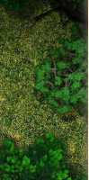**Archery NPGs**

Archer NPCs to pad out your NPCs. Scout (CR 1/4), Archer (CR 3), and Seasoned Hunter (CR 3) have some bases covered, but I wanted to get those other levels. Sharpshooter, Sniper, and Legendary Archer have the sharpshooter feat, making them high-damage dealing ranged opponents. Legendary Archer and Sniper should both be relatively nasty enemies at long range.

**Legendary Archer**

Medium humanoid, any alignment

**Armor Class 18 (studded leather armor) Hit Points 187 (25d8 + 36)**

**Speed 30 ft.**

**STR DEX CON INT WIS CHA**

**14 (+2) 22 (+6) 17 (+3) 12 (+1) 16 (+3) 10 (+0)**

**Saving Throws Str +8, Dex +12, Wis +9 Skills Acrobatics +12, Athletics +8, Perception +9, Stealth +12, Survival +9 Senses passive Perception 1 9 Languages Common Challenge 14 (8,400 XP)**

**Cunning Action.** The archer can take the Hide or Dash action as a bonus action. **Legendary Resistance (2/Day).** If the archer fails a saving throw, it can choose to succeed instead. **Sharpshooter.** Attacking at long range doesn't impose disadvantage on the archer's ranged weapon attack rolls. The ranged weapon attacks ignore half cover and three-quarters cover. **Skulker.** The archer can try to hide when it is lightly obscured from the creature from which you are hiding. When archer is hidden from a creature and misses it with a ranged weapon attack, making the attack doesn't reveal its position. Dim light doesn’t impose disadvantage on archer's Wisdom (Perception) checks relying on sight.

Actions

**Multiattack** The archer makes four weapon attacks. **Shortsword. Melee Weapon Attack:** +12 to hit, reach 5ft., one target. **Hit:** 8 (ld6 + 6) piercing damage. **Longbow Ranged Weapon Attack:** +12 to hit, range 600 ft, one target. **Hit 9** (ld8 + 6) piercing damage. **Longbow, Dead-eye Shot Ranged Weapon Attack: +7** to hit, range 600 ft., one target. **Hit** 19(1 d8 + 15) piercing damage.

**Sharpshooter**

Medium humanoid, any alignment

**Armor Class 14 (leather armor) Hit Points 39 (6d8 + 12) Speed 30 ft.**

**STR DEX CON INT WIS CHA**

**11 (+0) 1 7 (+3) 14 (+2) 11 (+0) 1 3 (+1) 10 (+0)**

**Skills Perception +3, Stealth +5 Senses passive Perception 1 3 Languages Common Challenge 2 (450 XP)**

**Sharpshooter.** Attacking at long range doesn't impose disadvantage on the sharpshooter's ranged weapon attack rolls. The sharpshooter's ranged weapon attacks ignore half cover and three-quarters cover.

Actions

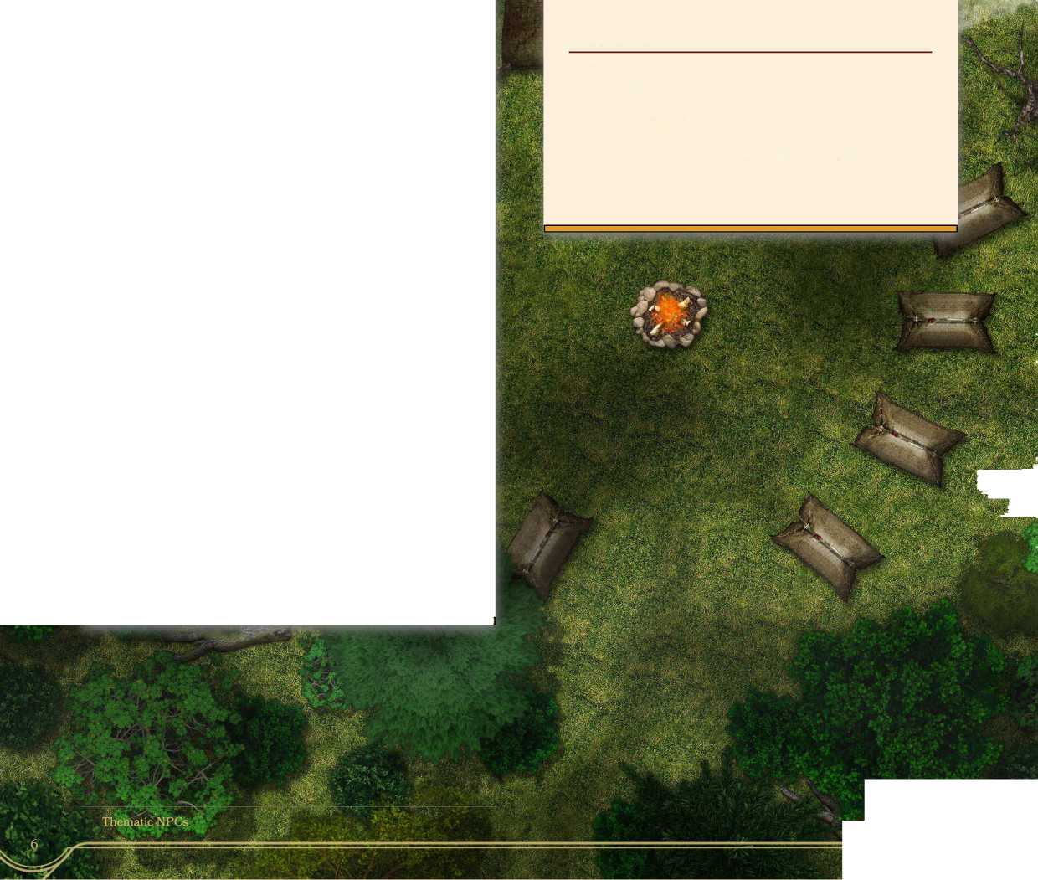**Multiattack.** The sharpshooter makes two weapon attacks. **Shortsword. Melee Weapon Attack:** + 5 to hit, reach 5 ft., one target. **Hit:** 6 (ld6 + 3) piercing damage. **Longbow Ranged Weapon Attack:** + 5 to hit, range 600 ft., one target. **Hit** 7 (ld8 + 3) piercing damage. **Longbow, Dead-eye Shot Ranged Weapon Attack: +0** to hit, range 600 ft., one target. **Hit** 17 (1 d8 + 1 3) piercing damage.

**Sniper**

Medium humanoid, any alignment

**Armor Class 17 (studded leather armor) Hit Points 90 (12d8 + 36)**

**Speed 30 ft.**

**STR DEX CON INT WIS CHA**

**14 (+2) 20 (+5) 16 (+3) 12 (+1) 15 (+2) 10 (+0)**

**Skills Acrobatics +8, Athletics +5, Perception +5, Stealth +8, Survival +5 Senses passive Perception 1 5 Languages Common Challenge 6 (2,300 XP)**

**Cunning Action.** The sniper can take the Hide or Dash action as a bonus action. **Sharpshooter.** Attacking at long range doesn't impose disadvantage on the sniper's ranged weapon attack rolls. The sniper's ranged weapon attacks ignore half cover and three-quarters cover. **Skulker.** The sniper can try to hide when it is lightly obscured from the creature from which you are hiding. When the sniper is hidden from a creature and misses it with a ranged weapon attack, making the attack doesn't reveal its position. Dim light doesn’t impose disadvantage on the sniper's Wisdom (Perception) checks relying on sight.

Actions

**Multiattack** The sniper makes three weapon attacks. **Shortsword. Melee Weapon Attack:** +8 to hit, reach 5ft., one target. **Hit:** 8 (ld6 + 5) piercing damage. **Longbow Ranged Weapon Attack:** +8 to hit, range 600 ft, one target. **Hit 9** (ld8 + 5) piercing damage. **Longbow, Dead-eye Shot Ranged Weapon Attack: +** 3 to hit, range 600 ft, one target. **Hit** 1 9 (ld8 + 1 5) piercing damage.

The sniper and other skulkers prefer to fight from a distance. They will orchestrate with their allies to make sure that they are firing with advantage as often as possible. They will stay as far away from their enemies as possible, using their long range and stealthy abilities to harass their foes, while not the most deadly in a single strike, a lone sniper can often route a much larger force. In lands contested with ores, ogres, gnolls and other dangerous humanoids, snipers make excellent hunters, staying well out of range of larger and more deadly opponents.



**c**

**Dark Arts NPCs**

Some NPCs, regardless of alignment, choose to mess with the dark arts. The following are humanoids who have dabbled with or have a connection with the dark arts. The Vermin Lord, specifically, is interesting because it is druidic in nature. The others have suffered from corruption or dabble in the dark arts in one way or another.

**Demonologist**

***Medium humanoid, any alignment***

**Armor Class 12 (1 5 with mage armor) Hit Points 83 (15d8 + 15)**

**Speed 30 ft.**

**STR DEX CON INT WIS CHA**

**10 (+0) 14 (+2) 12 (+1) 20 (+5) 10 (+0) 14 (+2)**

**Saving Throws Int +10, Wis +5 Skills Arcane +10, Religion +10, History +10, Persuasion +7**

**Senses passive Perception 10 Languages Common, Infernal, Abyssal Challenge 10 (5,900 XP)**

**Corrupted Humanoid**

***Medium humanoid, any evil***

**ExperiencedSummoner.** **The demonologist has advantage on Constitution saves to keep concentration on summoning spells. Spellcasting. The demonologist is a 1 5th-level spellcaster. Its spellcasting ability is Intelligence (spell save DC 18, + 10 to hit with spell attacks). The demonologist has the following wizard spells prepared: Cantrips (at will): acid splash, infestation, mage hand, poison spray, fire bolt**

**1 st level (4 slots): *find familiar, grease, Tenser's floating disk, unseen servant, mage armor* 2nd level (3 slots): *scorching ray, misty step* 3rd level (3 slots): *summon lesser demons, fireball, counterspell***

**4th level (3 slots): *dimension door, Evard's black***

***tentacles, summon greater demon***

**5 th level (3 slots): *cloud kill, infernal calling***

**6th level (1 slot): arcane gate**

**7th level (1 slot): plane shift, symbol**

**8th level (1 slot): *incendiary cloud, mind blank***

Actions

**Armor Class 10 Hit Points 22 (5d8) Speed 30 ft.**

**Dagger. Melee Attack: +7** **to hit, reach 5 ft. or range 20/60 ft., one target. Hit: 4 (ld4 + 2) piercing damage. Fire Bolt Ranged Spell Attack:** **+10 to hit, range 120 ft., one target. Hit: 16 (3d 10) fire damage.**

**STR**

**DEX**

**CON**

**INT**

**WIS**

**CHA**

**14 (+2) 10 (+0) 10 (+0) 11 (+0) 10 (+0) 1 5 (+2)**

**Senses darkvision 5 ft, passive Perception 10 Languages racial language + Infernal or Abyssal Challenge 1/2 (100XP)**

Actions

**Demonologists aren't always evil and may even be trying to permanently banish demons and devils from the prime material plane. Regardless of their goals, demonologists tread a dangerous path. They mess with dark powers beyond the understanding of mortals. Sometimes their meddling can lead to situations in and around the places they practice their arts.**

**Multiatttack.** **The corrupted humanoid makes two claw attacks. Claw. Melee Weapon Attack:** **+4 to hit, reach 5 ft., one target. Hit** **4 (ld4 + 2) slashing damage, the target must make a DC 12 Charisma save or they have disadvantage on their next attack.**

**Thrall**

Medium humanoid, any alignment

**Armor Class as NPC type Hit Points as NPC type Speed as NPC type**

**Vermin Lord**

Medium humanoid, any alignment

**Armor Class 1 5 (studded leather armor)**

**Hit Points 60 (Hd8 + 11)**

**Speed 30 ft.**

**STR DEX CON INT WIS CHA**

**9 (+0) 16(+3) 12 (+1) 10 (+0) 18 (+4) 14 (+2)**

**Damage Vulnerabilities radiant, psychic Damage Resistances fire, cold; bludgeoning,**

**piercing, and slashing from nonmagical weapons Languages Common, Infernal, Abyssal, telepathy unlimited ft. (with their master only)**

Thralls have been claimed by infernal masters. If thralls are reduced to 0 hit points by radiant or psychic damage, when they wake up, they are no longer thralls. Until then, they serve their master's will.

**Dire Rat**

Large beast, unaligned

|  |  |  |  |
| --- | --- | --- | --- |
| **Armor Class 1 3**  **Hit Points 39 (6dl0 + 6)**  **Speed 30 ft.** |  |  |  |
| **STR DEX CON** | **INT** | **WIS** | **CHA** |
| **12 (+1) 16(+3) 12 (+1)** | **5(-3)** | **10 (+0)** | **4 (-3)** |
| **Senses darkvision 60 ft, passive Perception 10 Languages - Challenge 1 (200 XP)** | | | |

**Keen Smell.** The rat has advantage on Wisdom (Perception) checks that rely on smell. **Pack Tactics.** The rat has advantage on an attack roll against a creature if at least one of the rat's allies is within 5 feet of the creature and the ally isn't incapacitated.

Actions

**Bite. Melee Weapon Attack:** + 5 to hit, reach 5ft., one target. **HitS** (2d4 + 3) piercing damage.

**Saving Throws Wisdom +8, Charisma +6 Skills Animal Handling +8, Nature +4, Stealth +7, Survival +8**

**Senses darkvision 60 ft, passive Perception 14 Languages Common, Infernal, Abyssal Challenge 6 (2,300 XP)**

Shapechanger (3/day) The lord can use a bonus action to polymorph into a rat, a large rat, swarm of rats, or a dire rat. It takes on the statistics of the creature it turn into, but keeps it's mental stats. If the form is reduced to 0 or less hit points, the lord changes back to its normal form and any additional damage is take off it's regular form's hit points. Any equipment the lord is carrying merges into its new form. **Spellcasting.** The lord is a 12th-level spellcaster. Its spellcasting ability is Wisdom (spell save DC 16, +8 to hit with spell attacks). The lord has the following druid spells prepared: Cantrips (at will): **poison spray, druidcraft, infestation, mold earth**

**1st level (4 slots):** beast bond, animal friendship, speak with animals, cure wounds **2nd level (3 slots):** earth bind, locate animals or plants, pass without trace, spike growth, heat metal **3rd level (3 slots):** conjure animals **(summons 8 swarms of rats),** plant growth, meld into stone **4th level (3 slots):** giant rat **(as** giant insect **but changes 10 rats into 10 giant rats),** blight **5 th level (2 slots):** awaken, insect plague **6th level (1 slot):** bones of the earth

Actions

**Multiattack** The lord makes two short sword attacks. **Shortsword. Melee Attack: +7** to hit, reach 5 ft. or range 20/60 ft., one target. Hit: 6 (ld6 + 3) piercing damage, and the target must make a DC 11 Constitution saving throw taking 10 (3d6) poison damage on a failed save, or save for half. **Hand Crossbow. Ranged Spell Attack:** +7 to hit, range 30/120 ft, one target. Hit: 6 (ld6 + 3) piercing damage, and the target must make a DC 11 Constitution saving throw taking 10 (3d6) poison damage on a failed save, or save for half.

**Transforming**

**Humanoid**

Medium humanoid, any evil

**Armor Class 10 (None) Hit Points 40 (9d8) Speed 30 ft., fly 10 ft.**

**STR DEX CON INT WIS CHA**

**17 (+3) 10 (+0) 10 (+0) 14 (+2) 10 (+0) 1 6 (+3)**

**Skills Aracana+5, Deception +6, Intimidation +6, Persuasion +6**

**Damage Resistances cold, fire, lightning; bludgeoning, piercing, and slashing, from nonmagical weapons**

**Senses darkvision 10 ft, passive Perception 10 Languages racial language + Infernal or Abyssal Challenge 2 (450 XP)**

Actions

**Multiatttack.** The humanoids make two claw attacks. **Claw. Melee Weapon Attack: +6** to hit, reach 5ft., one target. **Hit 6** (1 d6 + 3) slashing damage, the target must make a DC 14 Charisma save or they move at 1/2 of their normal speed and have disadvantage on attack rolls until the end of the humanoid's next turn.

In the process of transforming into a physical incarnation of a demon on the prime material play, transforming humanoids resemble their race but with long, vicious claws, barbed teeth, and a set of underdeveloped demon wings springing from their back. Once a corrupted humanoid, these pour lost souls have taken the next step in their devolution. Only the magic of a **greater restoration** or **wish** spell can revert the changes.

**Espionage**

For some options beyond Spy (CR 1), Master Thief (CR 5), and Assassin (CR 8) These statblocks offer some lower, medium, and higher-level options for rogue-based statblocks. I made sure they all have cunning action, but not necessarily all of the other rogue features.

**Informant**

***Medium humanoid, any alignment***

**Armor Class 12 (none)**

**Hit Points 9 (2d8)**

**Speed 30 ft.**

**STR DEX CON INT WIS CHA**

**10 (+0) 14 (+2) 11 (+0) 12 (+1) 13 (+1) 12 (+1)**

**Skills Deception +6, History + 3, Perception +3, Persuasion +6, Sleight of Hand +4, Stealth + 4 Senses passive Perception 1 3 Languages Common, Thieves' Cant, + 2 others Challenge 1/2 (100XP)**

**Infiltrator**

Medium humanoid, any alignment

**Armor Class 14 (leather armor) Hit Points 5 5 (10d8 + 10) Speed 30 ft.**

**STR DEX CON INT WIS CHA**

**10 (+0) 16 (+3) 12 (+1) 14 (+2) 13 (+1) 14 (+2)**

**Saves Dex +7, Int +5**

**Skills Deception +10, History + 6, Investigation +6, Perception +5, Persuasion +10, Sleight of Hand +10, Stealth +10 Senses passive Perception 1 5 Languages Common, Thieves' Cant + 2 others Challenge 4 (1,100 XP)**

**Cunning Action.** On each of its turns, the infiltrator can use a bonus action to take the Dash, Disengage, or Hide action. **Sneak Attack (1/Turn).** The infiltrator deals an extra 17 (5d6) damage when it hits a target with a weapon attack and has advantage on the attack roll, or when the target is within 5 feet of an ally of the infiltrator that isn't incapacitated and the infiltrator doesn't have disadvantage on the attack roll.

Actions

**Cunning Action.** On each of its turns, the informant can use a bonus action to take the Dash, Disengage, or Hide action. **Sneak Attack (1/Turn).** The informant deals an extra 3 (ld6) damage when it hits a target with a weapon attack and has advantage on the attack roll, or when the target is within 5 feet of an ally of the informant that isn't incapacitated and the informant doesn't have disadvantage on the attack roll.

Actions

**Dagger. Melee or Ranged Weapon Attack:** +4 to hit, reach 5ft. or range 20/60 ft., one target. **Hit:** 4 (1 d4 + 2) piercing damage.

As an informant will readily remind anyone who thinks other, informants are not active agents. They are typically just shady people who work with spies, the local guards, the local thieves' guild, or whoever will pay them the right coin. In a scrape, something very valuable has to be on the line for an informant to stick around a fight. They are much more likely to flee as quickly as possible. Despite a lack of bravery, informants can be valuable friends and contacts. They typically know the word on the street and have several black market contacts. However, the average adventurer is cautioned not to trust informants any more than necessary.

**Multiattack.** The infiltrator makes two weapon attacks. **Dagger. Melee or Ranged Weapon Attack:** +7 to hit, reach 5ft. or range 20/60 ft., one target. **Hit:** 5 (ld4 + 3) piercing damage.

**Thematic NPCs**

**Armor Class 18 (studded leather armor) Hit Points 163 (25d8 + 50)**

**Armor Class 16 (leather armor) Hit Points 97 (15d8 + 30) Speed 30 ft.**

**Intelligence Agent**

***Medium humanoid, any alignment***

**Legendary Operative**

***Medium humanoid, any alignment***

**Speed 30 ft.**

**STR DEX CON INT WIS CHA**

**10 (+0) 20 (+5) 14 (+2) 14 (+2) 14 (+2) 16 (+3)**

**STR DEX CON INT WIS CHA**

**10 (+0) 22 (+6) 14 (+2) 14 (+2) 14 (+2) 18 (+4)**

**Cunning Action.** **On each of its turns, the agent can use a bonus action to take the Dash, Disengage, or Hide action. Impostor.** **The agent must spend at least three hours listening to speech, examining handwriting, and observing mannerisms and can then impersonate the person. The agent's ruse is mn^m indiscernible to the casual observer. If a wary**

**creature suspects something is a miss, the agent has advantage on any Charisma (Deception) checks made to avoid detection. Sneak Attack (1/Turn).** **The agent deals an extra 28 (8d6) damage when it hits a target with a weapon attack and has advantage on the attack roll, or when the target is within 5 feet of an ally of the agent that isn't incapacitated and the agent doesn't have disadvantage on the attack roll.**

Actions

**Saves Dex +10, Int +7**

**Skills Deception +1 3, History +7, Investigation +7, Perception +7, Persuasion +1 3, Sleight of Hand +15, Stealth+15**

**Senses blindsight 10 ft, passive Perception 17 Languages Common, Thieves' Cant + 4 others Challenge 13 (10,000 XP)**

**Multiattack.** The agent makes two dagger attacks. **Dagger. Melee or Ranged Weapon Attack:** +10 to hit, reach 5ft. or range 20/60 ft, one target. **Hit: 1** (ld4 + 5) piercing damage and the target must make a DC 19 Constitution saving throw, taking 42 (12d6) poison damage on a failed save, or half as much damage on a successful one. **Light Crossbow.** Ranged Weapon Attack: +10 to hit, range 80/320 ft., one target. Hit: 7 (1 d8 + 5) piercing damage, and the target must make a DC 1 9 Constitution saving throw, taking 42 (12d6) poison damage on a failed save, or half as much damage on a successful one.

An intelligence agent uses Purple Worm poison, and adventurer who kills one might be lucky enough to find ld4 unused vials on the agent or in their belongings although finding a spy's stash can be almost impossible.

**Saves Dex +12, Int +8, Wis +8 Skills Deception +16, History +8, Investigation +8, Perception +8, Persuasion +16, Sleight of Hand +18, Stealth +18**

**Senses blindsight 10 ft, passive Perception 18 Languages Common, Thieves' Cant + 2 others Challenge 17 (18,000 XP)**

**Cunning Action.** On each of its turns, the operative can use a bonus action to take the Dash,

Disengage, or Hide action. **Legendary Resistance (2/Day).** If the operative fails a saving throw, it can choose to succeed instead. **Sneak Attack (1/Turn).** The operative deals an extra 3 5 (10d6) damage when it hits a target with a weapon attack and has advantage on the attack roll, or when the target is within 5 feet of an ally of the operative that isn't incapacitated and the operative doesn't have disadvantage on the attack roll. **Soul of Deceit** the operative's thoughts can’t be read by telepathy or other means, unless the operative allows it. The operative can present false thoughts by succeeding on a Charisma (Deception) check contested by the mind reader’s Wisdom (Insight) check. Additionally, no matter what the operative says, magic that would determine if the operative is telling the truth indicates it is being truthful if the operative so chooses, and the operative can’t be compelled to tell the truth by magic.

Actions

Multiattack **The operative makes two dagger attacks.** Dagger. Melee or Ranged Weapon Attack:

+ 12 to hit, reach 5ft. or range 20/60 ft., one target. **Hit:** 8 (ld4 + 6) piercing damage and the target must make a DC 1 9 Constitution saving throw, taking 42 (12d6) poison damage on a failed save, or half as much damage on a successful one. **Light Crossbow.** Ranged Weapon Attack: +12 to hit, range 80/320 ft., one target. Hit: 7 (1 d8 + 6) piercing damage, and the target must make a DC 19 Constitution saving throw, taking 42 (12d6) poison damage on a failed save, or half as much damage on a successful one.

**Holy NPCs**

To go with the acolyte (CR 1/8), priest (CR 2), heterodox priest (CR 5), and war priest (CR 9). These statblocks represent priests and those of faith in the established church, Martyr and Reverend Martyr are both designed to be part paladin and part cleric. Curate and Saint are both entirely cleric.

**Martyr**

***Medium humanoid, any alignment***

**Armor Class 1 5 (Half-Plate) Hit Points 68 (12d8 + 24) Speed 30 ft.**

**STR DEX CON INT WIS CHA**

**16(+3) 10 (+0) 14 (+2) 8 (-1) 16 (+3) 14 (+2)**



**Mace. Melee Attack:** **+4 to hit, reach 5 ft., one target. Hit: 6 (ld8 + 2) bludgeoning damage.**

**A curate is a normal cleric, but a little different from a priest. A curate is not a leader but a follower. Well behaved curates do paperwork, heal the sick, bash undead with their maces, and lay the dead to rest. A curate might be in charge of 1 d6 acolytes at any time, and probably reports to a priest or another higher ranking church official.**

**Curate**

Medium humanoid, any good or neutral alignment

**Armor Class 1 5 (Chain Mail) Hit Points 16 (3d8 + 3) Speed 30 ft.**

**STR DEX CON INT WIS CHA  
14 (+2) 8 (-1) 13 (+1) 10 (+0) 15 (+2) 12 (+1)**

**Saving Throws Wis +4, Char +3 Skills History +2, Medicine +4, Persuasion +3, Religion +2**

**Senses passive Perception 12 Languages Common, Celestial Challenge 1 (200 XP)**

**Spellcasting.** The curate is a 3rd-level spellcaster. Its spellcasting ability is Wisdom (spell save DC 12, +4 to hit with spell attacks). The curate has the following cleric spells prepared: Cantrips (at will): **light, spare the dying**

**1 st level (4 slots):** healing word, cure wounds, sanctuary

**2nd level (2 slots):** gentle repose, lesser restoration

Actions

**Saving Throws Wis +7, Cha +6 Skills Athletics +7, Insight +7, Perception +7, Religion +3**

**Senses passive Perception 1 3 Languages Common, Celestial Challenge 5 (1,800 XP)**

**Divine Eminence.** As a bonus action, the martyr can expend a spell slot to cause its melee weapon attacks to magically deal an extra 10 (3d6) radiant damage to a target on a hit. This benefit lasts until the end of the turn. If the martyr expends a spell slot of 2nd level or higher, the extra damage increases by Id6 for each level above 1st. **Spellcasting.** The martyr is a 7th-level spellcaster. Its spellcasting ability is Wisdom (spell save DC 1 5, +7 to hit with spell attacks). The martyr has the following spells prepared: Cantrips (at will): **light, spare the dying**

**1 st level (4 slots):** healing word, cure wounds, sanctuary, guiding bolt, bless **2nd level (3 slots):** gentle repose, lesser restoration, aid

3rd level (3 slots): **revivify, daylight** 4th level (1 slots): **divination**

Actions

**Multiattack.** The martyr makes two weapon attacks. **Creatsword. Melee Attack: +7** to hit, reach 5 ft, one target. Hit: 10 (2d6 + 3) slashing damage. **Guiding Bolt (costs 7 spell slot).** Ranged Spell Attack:- +7 to hit, range 120 ft., one target. Hit: 14 (4d6) radiant damage.

Whether through a specific set of circumstances, random chance, or being called by their deity directly, the martyr sees their own life as forfeit. Their only purpose in life is to fight the good fight and help others, with little to no regard for their own health and well-being. A martyr will lead the fight in the battlefield, throw themselves headlong into a dungeon, or stand up to traveling adventurers who come into town and throw their weight around. Nothing pisses off a martyr like a traveling barbarian pushing around the townsfolk and being an ass.

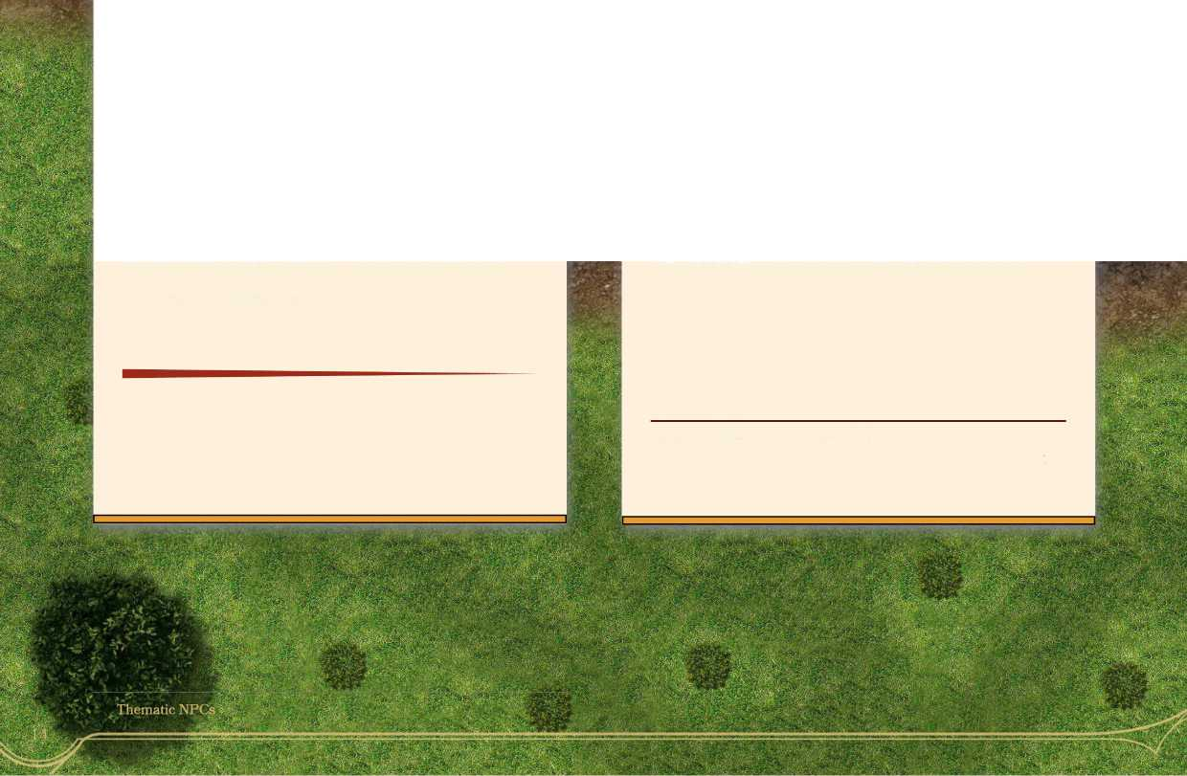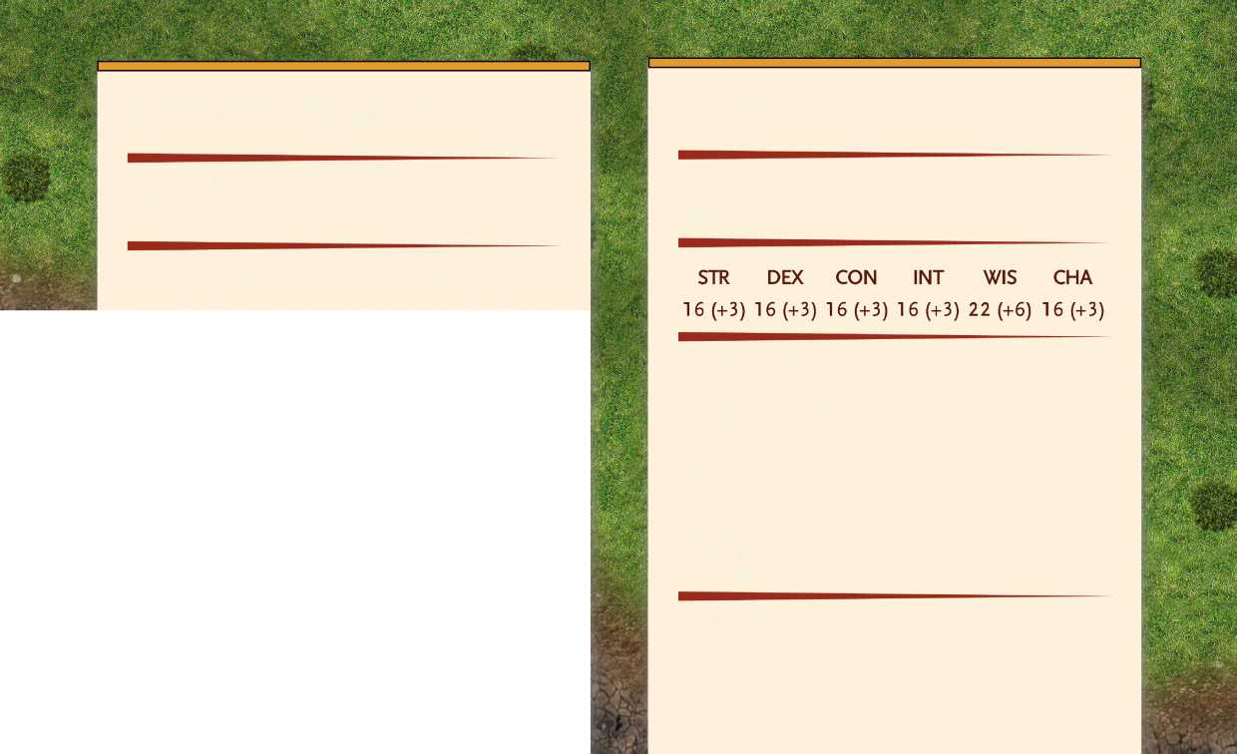

**Reverend Martyr**

***Medium humanoid, any alignment***

**Saint**

***Medium humanoid, any alignment***

**Armor Class 10 (rags) or 18 (plate mail) Hit Points 187(25d8 +7 5)**

**Speed 30 ft.**

**Armor Class 18 (plate mail) Hit Points 22 5 (30d8 + 90) Speed 30 ft.**

**STR DEX CON INT WIS CHA**

**18 (+4) 10 (+0) 16 (+3) 8 (-1) 16 (+3) 14 (+2)**

**Saving Throws Wis +9, Char +8 Skills Athletics +10, Insight +9, Perception +9, Religion +5**

**Senses passive Perception 1 3 Languages Common, Celestial Challenge 14 (11,5 00 XP)**

**Divine Eminence**\* As a bonus action, the martyr can expend a spell slot to cause its melee weapon attacks to magically deal an extra 10 (3d6) radiant damage to a target on a hit. This benefit lasts until the end of the turn. If the martyr expends a spell slot of 2nd level or higher, the extra damage increases by Id6 for each level above 1st. **Spellcasting.** The martyr is a 1 5th-level spellcaster. Its spellcasting ability is Wisdom (spell save DC 1 7, +9 to hit with spell attacks). The martyr has the following cleric spells prepared: Cantrips (at will): **light, spare the dying, guidance, sacred flame** 1 st level (4 slots): **healing word, cure wounds, sanctuary, guiding bolt, bless** 2nd level (3 slots): **gentle repose, lesser restoration, aid**

3rd level (3 slots): **revivify, daylight**

4th level (3 slots): **divination**

**5th level (2 slots):** mass cure wounds, holy weapon

6th level (1 slot): **heal**

7th level (1 slot): **divine word**

8th level (1 slot): **holy aura**

Actions

**Multiattack** The martyr makes two weapon attacks. **Greatsword. Melee Attack:** +10 to hit, reach 5 ft, one target. Hit: 11 (2d6 + 4) slashing damage. **Guiding Bolt (costs** 7 **spell slot).** Ranged Spell Attack:* +10 to hit, range 1 20 ft, one target. Hit: 14 (4d6) radiant damage.

**Damage Resistances necrotic; bludgeoning,**

**piercing, and slashing from nonmagical weapons Damage Immunities radiant Saving Throws Str +9, Dex +9, Con +9, Int +9, Wis +12, Cha +9**

**Skills Animal Ken +12, Athletics +9, History +9, Insight +9, Perception +9, Persuasion +9, Religion +9**

**Senses passive Perception 19 Languages Common, Celestial Challenge 18 (20,000 XP)**

**Spellcasting.** The saint is a 20th-level spellcaster. Its spellcasting ability is Wisdom (spell save DC 20,

+ 1 2 to hit with spell attacks). The saint has the following cleric spells prepared: Cantrips (at will): **guidance, light, mending, sacred flame, word of radiance**

**1 st level (4 slots):** heating word, bless, detect evil and good, detect poison and disease, cure wounds, purify food and drink, sanctuary, guiding bolt **2nd level (3 slots):** augury, gentle repose, lesser restoration, zone of truth **3rd level (3 slots):** clairvoyance, create food and water, mass healing word, remove curse, revivify, spirit guardians, tongues, water walk **4th level (3 slots):** banishment, divination **5th level (3 slots):** Commune, dispel evil and good, flame strike, greater restoration, mass cure wounds, raise dead **6th level (2 slot):** heal, harm, true seeing **7th level (2 slot):** conjure celestial, divine word **8th level (1 slot):** control weather **9th level (1 slot):** mass heal, true resurrection Turn Undead. **As an action, each undead that can see or hear the saint within 30 feet of them must make a Wisdom saving throw. If the creature fails its saving throw, it is turned for 1 minute or until it takes any damage. Undead of CR 4 or lower who fail their saving throw are instantly destroyed.**

Through the grace of their deity, the reverend martyr has managed to survive all of the scrapes they've been in over the years. However, their search for a righteous death hasn't abated, and they are as reckless as they are powerful.

Actions

**Guiding Bolt (costs** 7 **spell slot).** Ranged Spell Attack:* +12 to hit, range 120 ft, one target. Hit: 14 (4d6) radiant damage.

**Military NPGs**

The other resources have many military-type NPCs, especially in Versatile NPCs. All of the NPCs in this section have some type of ability or focus that fills gaps in the existing statblocks. Medic heals, sapper blows up, novice soldier flees (and is 1/2 human/humanoid), infantry captain is great with some support, etc.

**Legendary**

**SWORDMASTER**

***Medium humanoid, any alignment***

**Armor Class 18 (studded leather) Hit Points 225 (30d8 + 90)**

**Speed 40 ft.**

**Infantry Captain**

***Medium humanoid (any race), any alignment***

**STR DEX CON INT WIS CHA**

**14 (+2) 22 (+6) 16 (+3) 14 (+2) 16 (+3) 16 (+3)**

**Saving Throws Str +8, Dex +12 Skills Acrobatics +12, Athletics +8, History +8, Intimidation +9, Perception +9,**

**Senses passive Perception 12 Languages Common Challenge 14 (11,5 00 XP)**

**Armor Class 19 (splint mail, shield) Hit Points 91(14d8 + 28)**

**Speed 30 ft**

**STR DEX CON INT WIS CHA**

**16 (+3) 12 (+1) 14 (+2) 14 (+2) 11 (+0) 14 (+2)**

**Saving Throws Con + 5, Cha + 5 Skills Athletics +6, History + 4, Perception +3, Persuasion +5**

**Senses passive Perception 1 3 Languages Any One Language Challenge 6**

Actions

**Multiattack.** **The captain makes three melee attacks. Longsword(One-handed). Melee Weapon Attack:** +6 **to hit, reach 5ft., one target. Hit** **7 (1 d8 + 3)**

***Longsword (Two-handed). Melee Weapon Attack:*** +6 **to hit, reach 5ft., one target. *Hit*** **8 (ldlO + 3)**

**Commander's Strike.** **The captain may make one attack as a bonus action. Additionally, one creature of the captain's choice within 60 feet of it which can hear and understand it may use their reaction to make one attack with advantage.**

**Sound the Attack (Recharges after a short or long rest),** **up to 6 creatures of the captain's choice within 30 feet of it which can hear and understand it may use their reaction to move up to half of their movement speed and make one attack. Rally (Recharge 6).** **Up to 6 creatures of the captain's choice within 30 feet of it gain 5 temporary hit points. If any of them are frightened by a spell or ability that allows a saving throw to break the effect, those creatures may immediately make a saving throw to resist the effect.**

**BattlemasterManeuvers.** **Once per turn, the swordmaster can use one of the following effects:**

* **Lunging Attack: One of the swordmaster's attacks has a reach of 10 ft.**
* **Trip Attack: A larger or smaller creature hit by one of the swordmaster's attacks must make a DC 20 Strength save or be knocked prone.**
* **Sweeping Attack: When the swordmaster hits a creature with an attack, they may then make an additional attack to another creature within 5 feet of the original target that is within reach.**
* **Menacing Attack: When the swordmaster hits a creature with an attack, the creature must make a DC 20 Wisdom save or be frightened until the end of the swordmaster's next turn. Form Over Force.** **The swordmaster can use its Dexterity score instead of Strength to attack and damage with the longsword.**

Actions

**Multiattack.** **The swordmaster makes four weapon attacks. Longsword. Melee Weapon Attack:** + **12 to hit, reach 5ft., one target. Hit:** **12 (1 d8 + 8) piercing damage.**

Reaction

**Parry.** **When another creature damages the swordmaster, it can us its reaction to reduce the damage it takes by 1 3 (1 dl 2 + 6). Riposte.** **When a creature misses the swordmaster with a melee attack, they can use their reaction to make a melee weapon attack against the target.**

***WM***

**Medic**

Medium humanoid, any alignment

**—**

**Armor Class 1 5 (chain shirt)**

**Hit Points 22 (4d8 + 4)**

**Speed 30 ft.**

**Novice Soldier**

Medium humanoid, any alignment

**Armor Class 14 (chain shirt)**

**Hit Points 27 (5d8 + 5)**

**Speed 30 ft.**

**STR DEX CON INT WIS CHA**

**13 (+1) 14 (+2) 12 (+1) 10 (+0) 14 (+2) 12 (+0)**

**STR DEX CON INT WIS CHA**

**13 (+1) 12 (+1) 12 (+1) 10 (+0) 10 (+0) 10 (+0)**

**Skills Athletics +3, Medicine +4, Nature +2, Stealth +4**

**Senses passive Perception 12 Languages Common Challenge 1 (200 XP)**

**Healer.** When the medic uses a healer's kit to stabilize a dying creature, the creature then regains 1 hit point. Also, as an action, the medic can spend one use of a healer’s kit to tend to a creature and restore ld6 + 4 hit points to it, plus additional hit points equal to the creature’s maximum number of Hit Dice. The creature can’t regain hit points from this feature or the **healer feat** again until it finishes a short or long rest.

Actions

**Shortsword. Melee Weapon Attack: +4** to hit, reach 5ft, one target. **Hit:** 5 (ld6 + 2) piercing damage. **Light Crossbow Ranged Weapon Attack: +4** to hit, range 80/320 ft., one target. **Hit 6** (ld8 + 2) piercing damage.

**Skills Athletics +3, Perception +2 Senses passive Perception 12 Languages Common Challenge 1/2 (450 XP)**

Skittish: On each of its turns, the soldier may use its bonus action to take the Disengage action.

Actions

**Spear (2 handed). Melee Weapon Attack: +3** to hit, reach 5ft, one target. **Hit:** 6 (ld8 + 1) piercing damage. **Light Crossbow Ranged Weapon Attack: +3** to hit, range 80/320 ft, one target. **Hit 6** (ld8 + 1) piercing damage.

Not knowing what they got into, novice soldiers sometimes discover that discretion is the better part of valor.

While not masters of the battlefield, medics are the unsung heroes of wars. Braving the dangerous and chaotic environment of wars, medics go into the thick of it to lend aid to their allies. Some medics are members of the army, some are hired from local towns and hamlets, others are members of religious orders and sects who believe it is their duty to help others. In addition to healing the wounded, medics might also have other job functions as well such as caring for the wounded, stabilizing the unconscious, disposing of bodies, preparing healing ointments for scouting groups, or even just overseeing the overall health of the officers and commanders. No armed force is complete without medics in their number.

**Actions**

* **Skills Athletics +4, Perception +3**
* **Senses passive Perception 1 3**
* **Languages Common**
* **Challenge 1 (200 XP)**

***W***

**Set Versus Charge. As a bonus action, the pikeman chooses a creature it can see that is at least 20 feet away from it. If that creature moves within it's pike's reach on its next turn, the pikeman can make a pike melee attack against it as a reaction. If the attack hits, the target takes an extra 1 dl 0 slashing damage. The pikeman can't use this ability if the creature used the Disengage action before moving.**

**i**

**Sapper**

***Medium humanoid\ any alignment***

**Armor Class 14 (studded leather) Hit Points 3 9 (6d8 + 12)**

**Speed 30 ft.**

**STR DEX CON INT WIS CHA**

**12 (+1) 15 (+2) 14 (+2) 13 (+1) 10 (+0) 10 (+0)**

**Skills Athletics +3, Investigation +3, Stealth +4, Survival +2**

**Senses passive Perception 12 Languages Common Challenge 1 (200 XP)**

**—**

**Pike man**

***Medium humanoid, any alignment***

**—**

**Armor Class 1 5 (scale mail)**

**Hit Points 32 (5d8+ 10)**

**Speed 30 ft.**

**STR DEX CON INT WIS CHA**

**15 (+2) 13 (+1) 14 (+2) 10 (+0) 12 (+1) 10 (+0)**

**Coming from a long tradition of anti-cavalry units, pikemen are important units in mass warfare. In other situations, like underground cities and dungeons, pikemen can be useful because they can attack with melee from behind the first line of soldiers.**

**On the open battlefield, pikemen watch their surroundings closely, being ever-ready to be charged. After all, without shields the pikeman's best defense is a good offense.**

**Actions**

**Multiattack** **Pikeman makes two melee weapon attacks.**

**Cunning Action:** **On each of its turns, the sapper may use its bonus action to take the Dash, Dodge, or Disengage action.**

**I :**

**Pike. Melee Weapon Attack: +4 to hit, reach 10 ft, one target. Hit:** **7 (1 dl 0 + 2) slashing damage.**

**Shortsword. Melee Weapon Attack: +4** **to hit, reach 5ft., one target. Hit:** **6 (ld6 + 1) piercing damage.**

**Alchemist's Fire Ranged Weapon Attack:** +4 to hit, range 20 ft., one target. **Hit 2** (ld4) fire damage, the target continues to take damage every turn until it spends an action to make a DC 10 Dexterity check to extinguish the flames.

**Light Crossbow Ranged Weapon Attack:** **+3 to hit, range 80/320 ft, one target. Hit** **5 (ld8 + 1) piercing damage.**

**Savage Infantry**

Medium humanoid\ any alignment

|  |  |  |  |
| --- | --- | --- | --- |
| **Armor Class 1 3 (padded armor)** | |  |  |
| **Hit Points 7 5 (10d8 + 30) Speed 40 ft.** |  |  |  |
| **STR DEX CON** | **INT** | **WIS** | **CHA** |
| **18 (+4) 14 (+2) 16 (+3)** | **9 (■!)** | **12 (+1)** | **8(-l)** |

* Skills Athletics +6, Stealth +4, Survival +4
* Senses passive Perception 12
* Languages Common
* Challenge 3 (700 XP)

**Aggressive.** As a bonus action, the infantry can move up to its speed toward a hostile creature that it can see.

**Brute.** A melee weapon deals one extra die of its damage when the infantry hits with it (included in the attack).

**Reckless.** At the start of its turn, the infantry can gain advantage on all melee weapon attack rolls during that turn, but attack rolls against it have advantage until the start of its next turn.

**Actions**

**Multiattack.** The infantry makes two weapon attacks.

**j**

**Battleaxe. Melee Weapon Attack: +6** **to hit, reach 5ft., one target. Hit:** **16 (2d 10 + 4) slashing damage.**

**Monastic NPGs**

There are only a handful of monk NPC templates, Brawler (CR 1/2) and Martial Arts Adept (CR 3) to name two (the only two?) This section outlines many more, especially the all- powerful grand master.

**Grand Master**

Medium humanoid, any alignment

**Armor Class 20 (none)**

**Hit Points 187 (25d8 + 75)**

**Speed 60 ft.**

**STR DEX CON INT WIS CHA**

**14 (+2) 22 (+6) 16 (+3) 14 (+2) 18 (+4) 14 (+2)**

* Saving Throws St +8, Dex +12, Con +9, Int +8, Wis +10, Cha+8
* Damage Immunities poison
* Condition Immunities poisoned
* Skills Acrobatics +12, Insight +10, Medicine + 10, Stealth+12
* Senses passive Perception 14
* Languages Common, understands all spoken languages
* Challenge 17 (18,000 XP)

**Cunning Actions.** The master can take the Dodge, Disengage, or Dash action as a bonus action on their turn. If the master takes the dash action, it's jump distance is tripled (42 feet).

**Ki-EmpoweredStrikes.** The master's unarmed strikes count as magical for the purposes of overcoming resistance and immunity to nonmagical attacks and damage.

a

If it succeeds, it takes 5 5 (1 Odl 0) necrotic damage. Only one creature can be affected at a time. The master can choose to end the vibrations harmlessly without using an action.

**Tranquility.** The master enters a special meditation that surrounds them with an aura of peace. At the end of a long rest, they gain the effect of a sanctuary spell that lasts until the start of their next long rest (the spell can end early as normal). The saving throw DC for the spell equals 18.

**• v *r^773IW***

**Unarmored Defense.** The master's AC equals 10 + Dexterity modifier + Wisdom modifier when wearing no armor and not using a shield.

**Unarmored Movement** The master has the ability to move along vertical surfaces and liquids without falling during their move.

**BfVj* y • . «**

**3**

**M \** j

**Quivering Palm (3/day).** **The master has the ability to set up lethal vibrations in someone’s body. When the master hits a creature with an unarmed strike, it starts these imperceptible vibrations, which last for 20 days.**

**Actions**

**If the master uses their action to end the vibrations and the target is on the same plane of existence, the creature must make a DC 18 Constitution saving throw or it is reduced to 0 hit points.**

**Multiattack.** **The master makes 4 unarmed strike attacks or 3 dart attacks.**

**;**

**Sacred Fist**

Medium humanoid, any alignment

**Actions**

**Armor Class 17 (none)**

**Hit Points 97 (15d8 + 30) Speed 5 5 ft.**

**Multiattack** **The fist makes 4 unarmed strike attacks or 3 dart attacks.**

**Saving Throws Str+ 5, Dex +9, Con +7, Int +6**

**Wis+8, Cha+5**

**Damage Immunities poison**

**Condition Immunities poisoned**

**Skills Acrobatics +4, Insight +3, Stealth +4**

**Senses passive Perception 1 3**

**Languages Common, understands all spoken**

**languages**

**Challenges (3,900XP)**

**Unarmed strike. Melee Weapon Attack: +9** **to hit, reach 5 ft., one target. Hit:** **8 (ld8 + 4) bludgeoning damage. If the target is a creature, the fist can choose one of the following additional effects:**

* **The target must succeed on a DC 1 5 Strength saving throw or drop one item it is holding (fist's choice).**
* **The target must succeed on a DC 1 5 Dexterity saving throw or be knocked prone.**
* **The target must succeed on a DC 1 5 Constitution saving throw or be stunned until the end of the fist's next turn.**

**Cunning Actions.** **The fist can take the Dodge, Disengage, or Dash action as a bonus action on their turn. If the fist takes the dash action, it's jump distance is tripled (30 feet).**

**Dart Ranged Weapon Attack: +9** **to hit, range 20/60 ft., one target. Hit: 6 (Id4 + 4) piercing damage.**

**Ki-EmpoweredStrikes.** **The fist's unarmed strikes count as magical for the purposes of overcoming resistance and immunity to nonmagical attacks and damage.**

**Reactions**

**Timeless Body. The fist's ki sustains them so that they suffer none of the frailty of old age and can't be aged magically. They can still die of old age, however. In addition, they no longer need food or water.**

**Deflect Missiles.** **The fist can us its reaction to deflect or catch missiles when hit by ranged attacks. The damage of the attack is reduced by 9 (ldlO + 4).**

**Unarmored Defense.** **The fist's AC equals 10 + Dexterity modifier + Wisdom modifier when wearing no armor and not using a shield.**

**Unarmored Movement** **The fist has the ability to move along vertical surfaces and liquids without falling during their move.**

**Unlike the other monks, a sacred fist is named for a specific purpose. Whether to seek out an enemy, punish with wicked, or protect a place of importance or power. Due to their ability to survive without food or drink, some sacred fists are taken to remote or virtually inaccessible locations and tasked as guardians of ancient libraries, temples, tombs, or vaults.**

**Tfrematip**

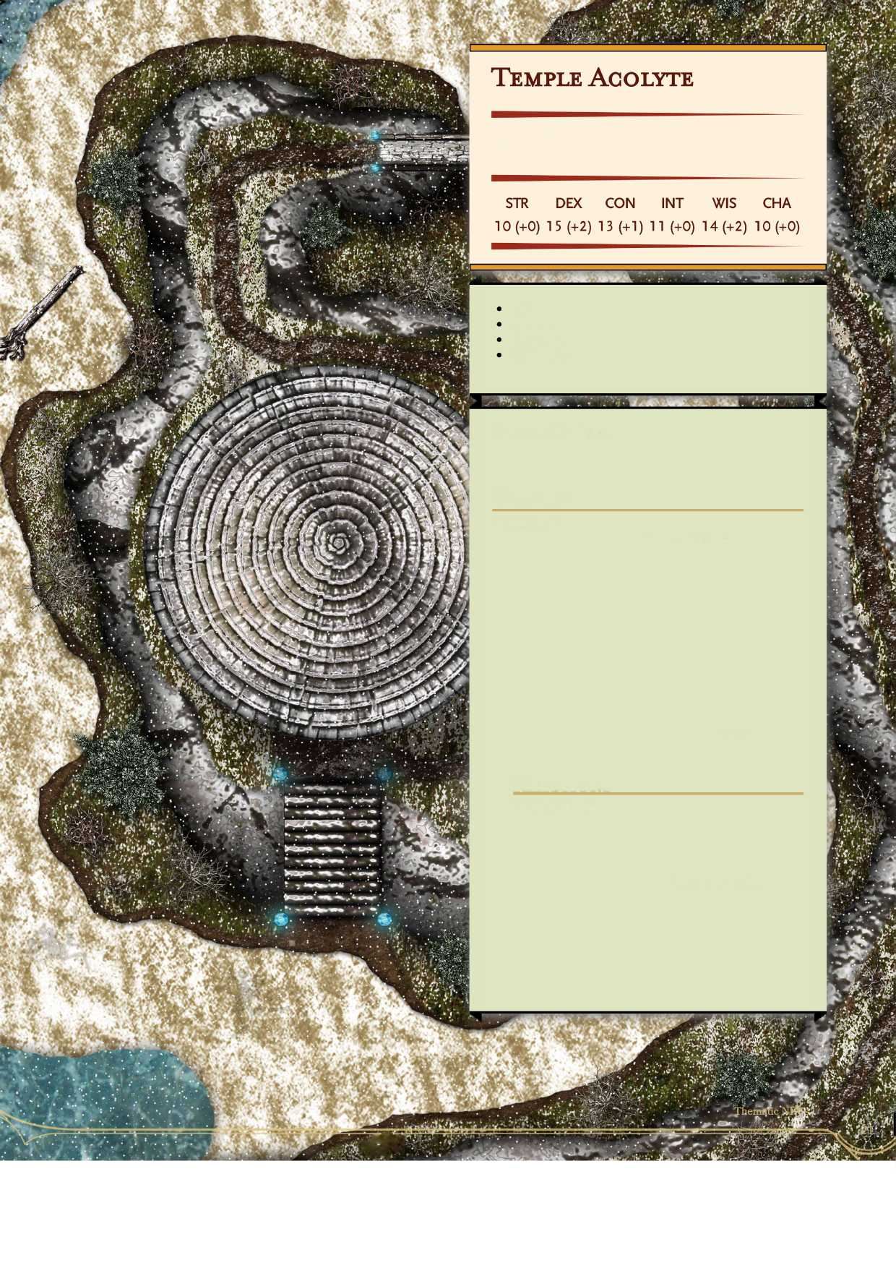Medium humanoid\ any alignment

**Armor Class 14 (none) Hit Points 16 (3d8 + 3) Speed 40 ft.**

Skills Acrobatics +4, Insight +3, Stealth +4 Senses passive Perception 12 Languages Common Challenge 1/2 (450 XP)

**Unarmored Defense.** The acolyte's AC equals 10 + Dexterity modifier + Wisdom modifier when wearing no armor and not using a shield.

**Actions**

**Multiattack** The acolyte makes 2 unarmed strike attacks or 2 dart attacks. **Unarmed strike. Melee Weapon Attack: +4** to hit, reach 5 ft, one target. **Hit:** 4 (1 d4 + 2) bludgeoning damage. If the target is a creature, the acolyte can choose one of the following additional effects:

* The target must succeed on a DC 1 2 Strength saving throw or drop one item it is holding (acolyte's choice).
* The target must succeed on a DC 12 Dexterity saving throw or be knocked prone.
* The target must succeed on a DC 12 Constitution saving throw or be stunned until the end of the acolyte's next turn. **Dart Ranged Weapon Attack: +4** to hit, range 20/60 ft, one target. Hit: 4 (Id4 + 2) piercing damage.

**Reactions**

**Deflect Missiles.** The acolyte can us its reaction to deflect or catch missiles when hit by ranged attacks. The damage of the attack is reduced by 7 (ldlO+2).

As opposed to holy acolytes, temple acolytes are trained in hand to hand combat, but mostly they are free labor. Temple acolytes tend the grounds, cook, clean, and perform all of the needed day to day functions of their temple or monastery in hopes that such mundane and banal chores will eventually lead to enlightenment.

|  |  |
| --- | --- |
|  | **JB&jp**1 |
| V | **pîpv** |

**Seafaring NPGs**

These are some seafaring NPCs. I normally use brigands (CR 1/8) and brigand leader (CR 2) for pirate and pirate captains, but these NPC statblocks are specifically for pirates and sailors. These stablocks make use of the mariner feat from Unearthed Arcana. I hope that makes it into print at some point.

**Tavern Brawler.** **If the boss hits a creature with an unarmed strike or improvised weapon, it can use a bonus action to attempt to grapple the target.**

**Actions**

**Deck Boss**

Medium humanoid, any alignment

**Armor Class 16 (studded leather armor) Hit Points 105 (14d8 + 42)**

**Speed 30 ft., swim 30 ft., climb 30 ft.**

**Multiattack** The boss makes three melee weapon attacks or two ranged weapon attacks.

Mace. **Melee Weapon Attack: +7** to hit, reach 5 ft., one target. **Hit:** 12 (2d8 + 3) bludgeoning damage.

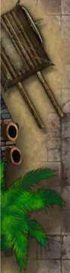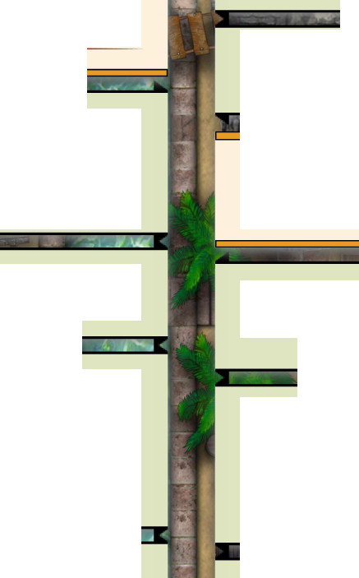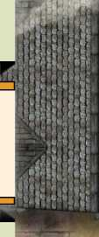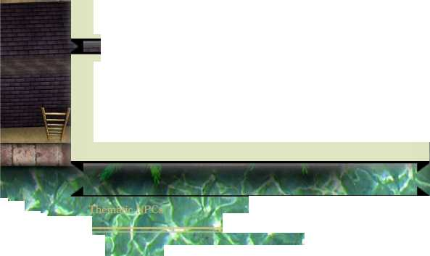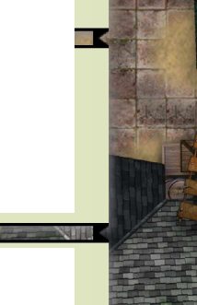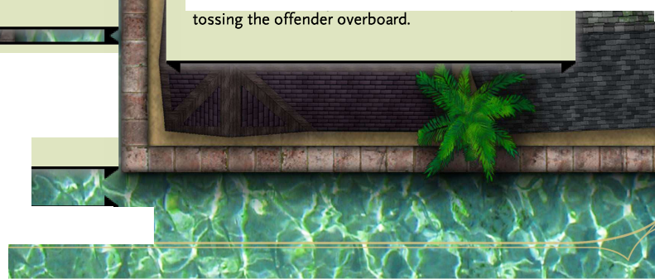

**STR DEX CON INT WIS CHA**

**16 (+3) 16 (+3) 16 (+3) 10 (+0) 10 (+0) 14 (+2)**

**Brute.** **The boss does an extra die of damage with melee attacks.**

**Charger.** **When the boss uses its action to dash, is can use a bonus action to make one melee weapon attack or to shove a creature. If it moves at least 10 feet in a straight line immediately before taking this bonus action, the boss can either gain a +5 bonus to the attack's damage roll or push the target up to 10 feet away from it.**

Skills Athletics +7, Deception +6, Intimidation +6, Perception +4, Persuasion +6,

Senses passive Perception 1 5 Languages Common, Thieves' Cant Challenge 6 (2,300 XP)

■

**Whip. Melee Weapon Attack:** **+7 to hit, reach 10 ft, one target. Hit:** **8 (2d4 + 3) piercing damage.**

**Improvised Weapon or Unarmed Strike. Melee Weapon Attack:** +7 to hit, reach 5 ft., one target. **Hit:** 8 (2d4 + 3) bludgeoning damage.

**Heavy Crossbow. Ranged Weapon Attack: +1** **to hit, range 100/400 ft., one target. Hit: 8 (Idl 0 + 3) piercing damage.**

**Also good as a first mate, the deck boss helps keep order on the ship. Whether a pirate ship, slaver ship, war galley or just normal merchant feighter, life at sea is hard and in addition to the leadership provided by the ship's captain, the deck boss bolsters that with a health dose of fear.**

**Crossbow Expert** The boss ignores the loading property of crossbows.

-Ji

**Mariner.** As long as the boss is not wearing heavy armor or using a shield, it has a swimming and climbing speed equal to its normal speed, and gains a +1 to AC.

***ItsvÆL***

A brutish person and practiced wrestler, the deck boss answers even possible insubordination by

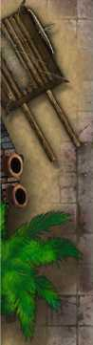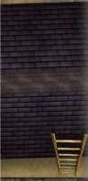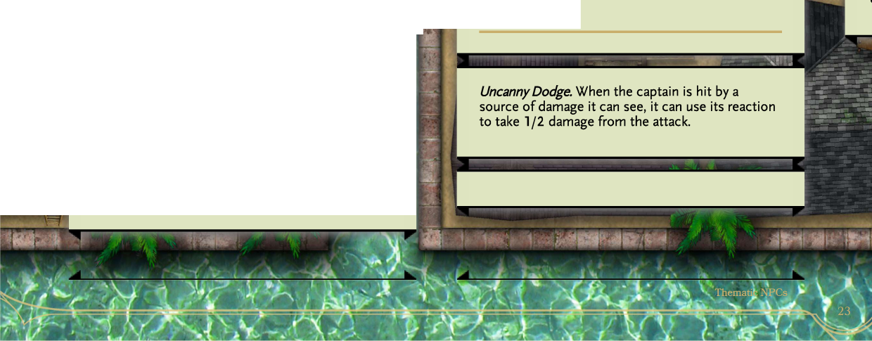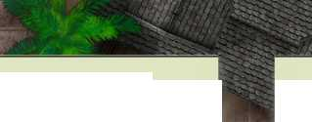image29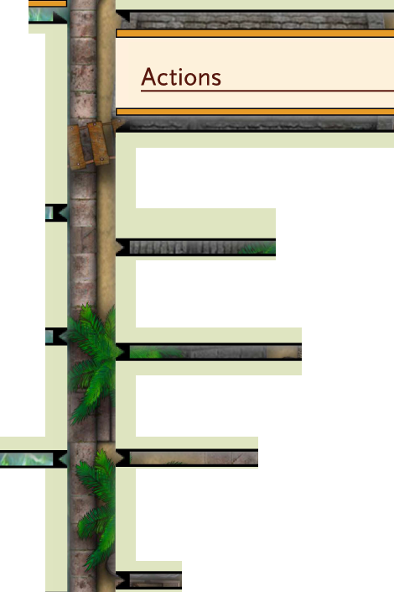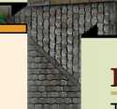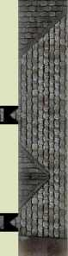

**—**

**Cunning Action.** On each of its turns, the captain can use a bonus action to take the Dash, Disengage, or Hide action.

**Reactions**

**Rakish Audacity. The** captain adds it's Charisma bonus to initiative rolls.

**Whip. Melee Weapon Attack: +9** to hit, reach 10 ft, one target. **Hit:** 6 (1 d4 + 4) piercing damage.

**Infamous Pirate Captain**

Medium humanoid, any alignment

**Armor Class 17 (studded leather armor)**

**Hit Points X(20d8 + 40)**

**Speed 30 ft., swim 30 ft., climb 30 ft.**

**STR DEX CON INT WIS CHA**

1. **(+1) 18 (+4) 14 (+2) 12 (+1) 14 (+2) 16 (+3)**

11« VI

Saving Throws Dex +9, Int +6, Wis +7 Skills Acrobatics +9, Athletics +6, Deception +8, Insight+7, Intimidation +8, Perception +7, Persuasion +8, Sleight of Hand +9, Stealth +9 Senses passive Perception 17 Languages Common, Thieves' Cant Challenge 9 (5,000 XP)

**Crossbow Expert** Hand crossbows count as melee weapons for the captain, and it ignores the loading property.

**Mariner.** As long as the captain is not wearing heavy armor or using a shield, it has a swimming and climbing speed equal to its normal speed, and gains a+1 to AC.

**Panache. As** an action, the captain can make a Charisma (Persuasion) check contested by a creature's Wisdom (Insight) check. The creature must be able to hear and understand the captain. If the captain succeeds, the creature has disadvantage on attack rolls against targets other than the captain and can't make opportunity attacks against targets other than the captain. This effect lasts for 1 minute, until one of captain's companions attacks the target or affects it with a spell, or until the captain and the target are more than 60 feet apart.

**:**

**Sneak Attack (1/Turn).** The captain deals an extra 21 (6d6) damage when it hits a target with a weapon attack and has advantage on the attack roll, when the target is within 5 feet of an ally of the captain that isn't incapacitated and the captain doesn't have disadvantage on the attack roll, or if no creature other than the target is within 5 feet of the captain.

**Multiattack** The captain makes two rapier attacks and one whip or hand crossbow attack, two hand crossbow attacks, or two whip attacks.

**Rapier. Melee Weapon Attack: +9** to hit, reach 5 ft., one target. **Hit:** 8 (ld8 + 4) piercing damage.

**Hand Crossbow. Melee or Ranged Weapon Attack:** +9 to hit, range 20/60 ft, one target. Hit: 7 (Id6 + 4) piercing damage.

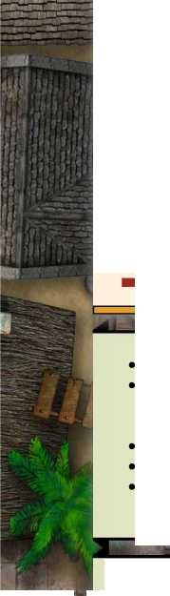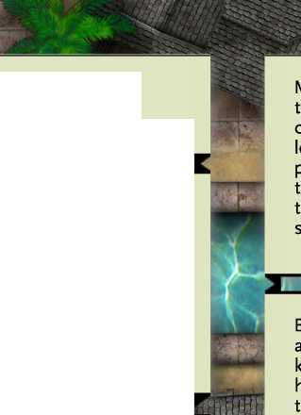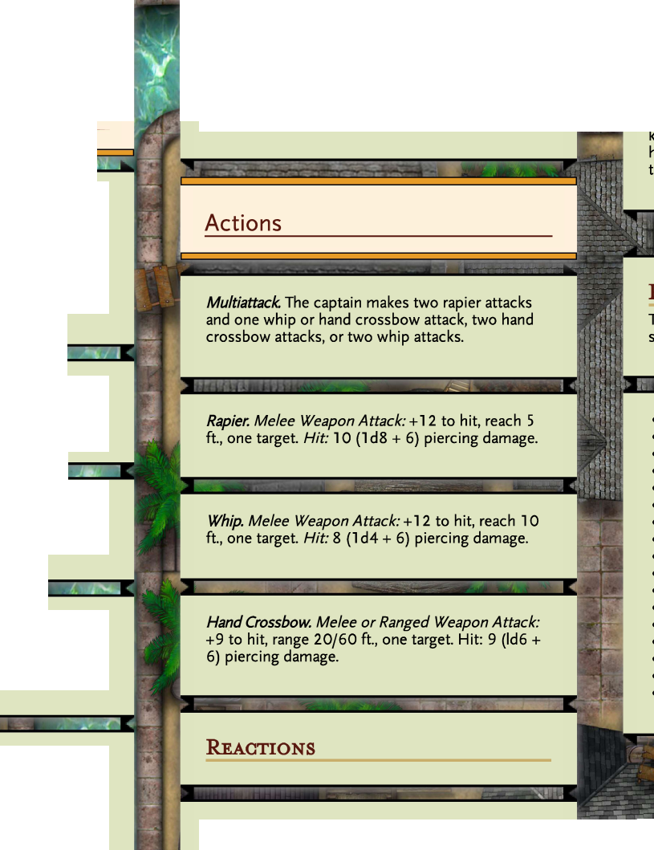**Legendary Pirate Captain**

**Crossbow Expert** **Hand crossbows count as melee weapons for the captain, and it ignores the loading property.**

**Cunning Action.** On each of its turns, the captain can use a bonus action to take the Dash, Disengage, or Hide action.

**Rakish Audacity. The** captain adds it's Charisma bonus to initiative rolls.

**Uncanny Dodge.** When the captain is hit by a source of damage it can see, it can use its reaction to take 1/2 damage from the attack.

Medium humanoid, any alignment

**Armor Class 19 (studded leather armor)**

**Hit Points 210 (28d8 +84)**

**Speed 30 ft., swim 30 ft., climb 30 ft.**

**STR DEX CON INT WIS CHA**

**14 (+2) 22 (+6) 16 (+3) 14 (+2) 14 (+2) 18 (+3)**

Saving Throws Dex +10, Int +8, Wis +8 Skills Acrobatics +18, Athletics +8, Deception +9, Intimidation +9, Perception +8, Persuasion + 1 5, Sleight of Hand +18, Stealth +18 Senses blindsight 10 ft, passive Perception 18 Languages Common, Thieves' Cant Challenge 1 5 (1 3,000 XP)

**Mariner.** As long as the captain is not wearing heavy armor or using a shield, it has a swimming and climbing speed equal to its normal speed, and gains a +1 to AC.

**Panache. As** an action, the captain can make a Charisma (Persuasion) check contested by a creature's Wisdom (Insight) check. The creature must be able to hear and understand the captain. If the captain succeeds, the creature has disadvantage on attack rolls against targets other than the captain and can't make opportunity attacks against targets other than the captain. This effect lasts for 1 minute, until one of the captain's companions attacks the target or affects it with a spell, or until the captain and the target are more than 60 feet apart.

**Sneak Attack (1/Turn).** The captain deals an extra 3 5 (10d6) damage when it hits a target with a weapon attack and has advantage on the attack roll, when the target is within 5 feet of an ally of the captain that isn't incapacitated and the captain doesn't have disadvantage on the attack roll, or if no creature other than the target is within 5 feet of the captain.

image39image40

**whenever possible. Instead, they will throw daggers or javelins at opponents, fleeing when necessary.**

**Sailor**

Medium humanoid, any alignment

In combat, a sailor is likely to avoid melee combat

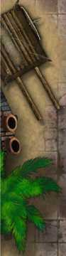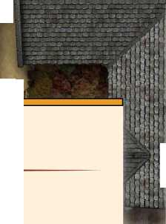

**'S»,**

**Armor Class 1 3 (leather armor)**

**Hit Points 17 (3d8 + 3)**

**Speed 30 ft., swim 30 ft., climb 30 ft.**

**STR DEX CON INT WIS CHA**

**12 (+1) 13 (+1) 12 (+2) 10 (+0) 10 (+0) 8 (-1)**

* **Skills Athletics +3, Perception +2**
* **Senses passive Perception 1 3**

**• Languages Common alle**

**Challenge 1/4 (50 XP)**

**pi**

**-j**

**Mariner; As long as the sailor is not wearing heavy armor or using a shield, it has a swimming and climbing speed equal to its normal speed, and gains a +1 to AC.**

**Actions**

**It *i**

**LjL**

**Pirate**

Medium humanoid, any alignment

**Armor Class 1 3 (none)**

**Hit Points 28 (5d8 + 5)**

**Speed 30 ft., swim 30 ft, climb 30 ft.**

**Dagger. Melee or Ranged Weapon Attack:** **+3 to hit, reach 5 ft. or 20/60 ft, one target. Hit:** **3 (1 d4 + 1) piercing damage.**

**STR DEX CON INT WIS CHA**

**13 (+1) 15 (+2) 14 (+2) 10 (+0) 10 (+0) 12 (+1)**

**Javelin. Ranged Weapon Attack:** **+3 to hit, 20/60 ft., one target. Hit: 4** **(ld6 + 1) piercing damage.**

**I**

* **Skills Athletics +3, Acrobatics +6, Sleight of Hand +4, Perception +5, Intimidation +3**
* **Senses passive Perception 1 5**
* **Languages Common, Thieves' Cant**
* **Challenge 1 (200 XP)**

Whether impressed into service or because they voluntarily entered the trade, being a sailor is hardly the safest and easiest profession available in the known realms. The life is fraught with peril, if not from harpies, krakens, Kua-Toa, pirates and other terrors of the sea, even a sailor's comrades might be the end of them. As a result, sailor's often adopt a "work hard, play hard" mentality.

**Cunning Action.** On each of its turns, the pirate can use a bonus action to take the Dash, Disengage, or Hide action.

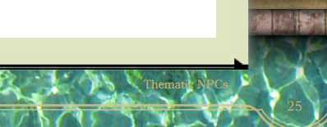**Mariner.** As long as the pirate is not wearing heavy armor or using a shield, it has a swimming and climbing speed equal to its normal speed, and gains a +1 to AC.

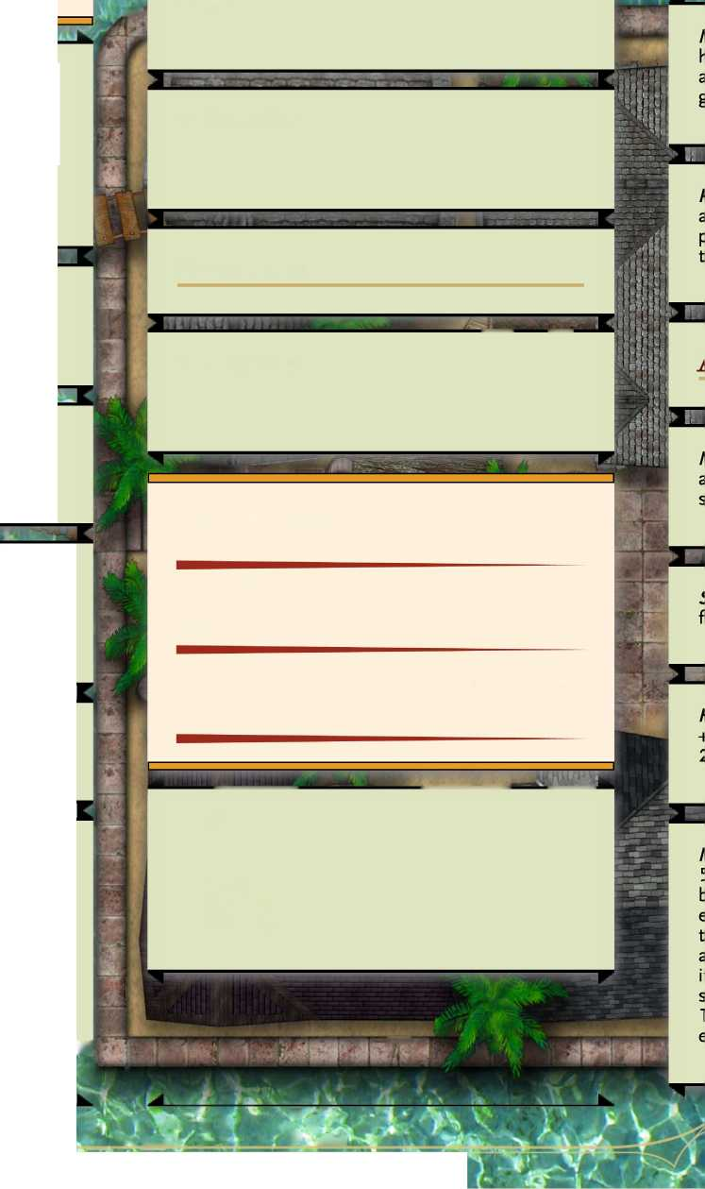

**Pirate Captain**

***Medium humanoid, any alignment***

**Armor Class 16 (studded leather armor)**

**Hit Points 78 (12d8 + 24)**

**Speed 30 ft, swim 30 ft., climb 30 ft.**

**STR DEX CON INT WIS CHA**

**12 (+1) 17 (+3) 14 (+2) 12 (+1) 12 (+1) 15 (+2)**

**Multiattack.** **The captain makes two rapier attacks and one hand crossbow attack, or two hand crossbow attacks.**

**a**

-

**Rapier. Melee Weapon Attack: +1** **to hit, reach 5 ft, one target. Hit: 1** **(ld8 + 3) piercing damage.**

'K*'-.

**Hand Crossbow. Melee or Ranged Weapon Attack: +7 to hit, range 20/60 ft, one target. Hit: 6 (Id6 + 3) piercing damage.**

Skills Acrobatics +11, Athletics +5, Deception + 5, Insight +5, Intimidation +10, Perception + 5, Persuasion +6, Sleight of Hand +11, Stealth + **11**

Senses passive Perception 1 5 Languages Common, Thieves' Cant Challenge 5 (1,800 XP)

**Reactions**

**Crossbow Expert** Hand crossbows count as melee weapons for the captain, and it ignores the loading property.

**Uncanny Dodge.** When the captain is hit by a source of damage it can see, it can use its reaction to take 1/2 damage from the attack.

image45

**Cunning Action.** **On each of its turns, the captain can use a bonus action to take the Dash, Disengage, or Hide action.**

**T7TT**

**Privateer**

***Medium humanoid, any alignment***

**Armor Class 1 3 (none)**

**Hit Points 28 (5d8 + 5)**

**Speed 30 ft., swim 30 ft., climb 30 ft.**

**Mariner.** As long as the captain is not wearing heavy armor or using a shield, it has a swimming and climbing speed equal to its normal speed, and gains a+1 to AC.

**Rakish Audacity.** **The captain adds it's Charisma bonus to initiative rolls.**

**STR DEX CON INT WIS CHA**

1. **(+1) 15 (+2) 14 (+2) 10 (+0) 10 (+0) 12 (+1)**

LuiilLlL

* **Skills Athletics +3, Intimidation +3, Perception +2, Persuasion +3, Sleight of Hand +4, Stealth +4**
* **Senses passive Perception 1 5**
* **Languages Common, Thieves' Cant**
* **Challenge 1 (200 XP)**

3

**Sneak Attack (1/Turn).** The captain deals an extra 14 (4d6) damage when it hits a target with a weapon attack and has advantage on the attack roll, when the target is within 5 feet of an ally of the captain that isn't incapacitated and the captain doesn't have disadvantage on the attack roll, or if no creature other than the target is within 5 feet of the captain.

jZ Fj ",

**rn**

***&***

■ ‘ __L

*■*

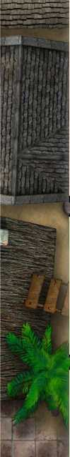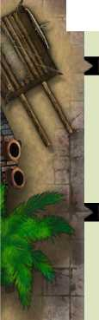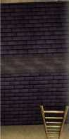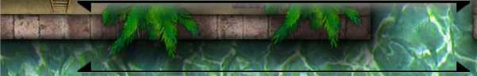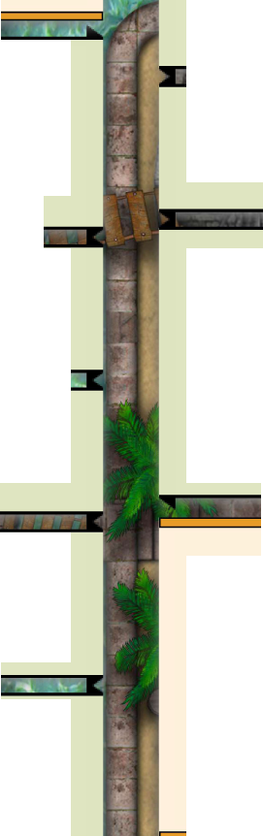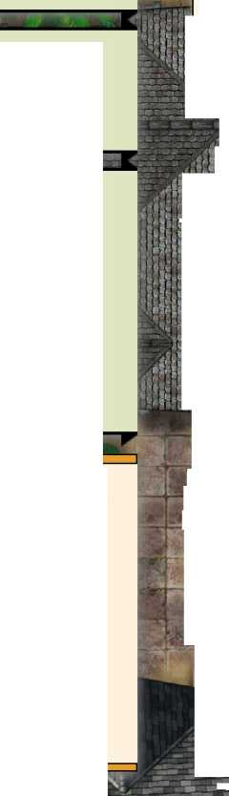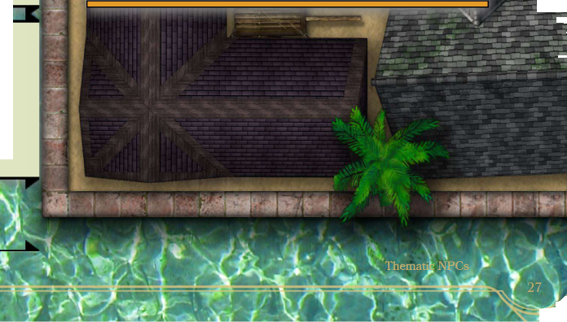

№

|  |  |  |
| --- | --- | --- |
| p1  **\* iST'\*** | **Multiattack.** **The privateer makes two scimitar** |  |
|  | **attacks, two hand crossbow attacks, or one** |  |
| **HP** | **scimitar and one crossbow attack.** |  |

**Scimitar. Melee Weapon Attack:** **+6 to hit, reach 5 ft, one target. Hit:** **6 (ld6 + 3) piercing damage.**

**Veteran Privateer**

Medium humanoid, any alignment

^—

**Armor Class 16 (studded leather armor) Hit Points 65 (10d8 + 20)**

**Speed 30 ft., swim 30 ft., climb 30 ft.**

**STR DEX CON INT WIS CHA**

1. **(+2) 16 (+3) 14 (+2) 10 (+0) 10 (+0) 12 (+1)**

* Skills Athletics +5, Intimidation +4, Perception +3, Persuasion +4, Sleight of Hand +6, Stealth **+6**
* Senses passive Perception 1 5
* Languages Common, Thieves' Cant
* Challenge 4 (1,100 XP)

**Crossbow Expert** Hand crossbows count as melee weapons for the privateer, and it ignores the loading property.

**Cunning Action.** On each of its turns, the privateer can use a bonus action to take the Dash, Disengage, or Hide action.

,

**Mariner.** As long as the privateer is not wearing heavy armor or using a shield, it has a swimming and climbing speed equal to its normal speed, and gains a +1 to AC.

**Pack Tactics.** The privateer has advantage on an attack roll against a creature if at least one of the privateer's allies is within 5 feet of the creature and the ally isn't incapacitated.

**Sneak Attack (1/Turn).** The privateer deals an extra 10 (3d6) damage when it hits a target with a weapon attack and has advantage on the attack roll, or when the target is within 5 feet of an ally of the privateer that isn't incapacitated and the privateer doesn't have disadvantage on the attack roll.

**Hand Crossbow. Melee or Ranged Weapon Attack:** +6 to hit, range 20/60 ft, one target. Hit: 6 (Id6 + 3) piercing damage.

**Net Melee Weapon Attack:** +6, reach 5ft. or range 5/15 ft., one target. A Large or smaller creature hit by a net is restrained until it is freed. A net has no effect on creatures that are formless, or creatures that are Huge or larger. A creature can use its action to make a DC 10 Strength check, freeing itself or another creature within its reach on a success. Dealing 5 slashing damage to the net (AC 10) also frees the creature without harming it, ending the effect and destroying the net.

While pirates and pirate captains are fierce in their own right, privateers and veteran privateers specialize in teamwork and working together. They've learned that fortune favors the force with both overwhelming numbers and a single mindset. As a result, privateers will use the ship environment to their advantage, climbing up rigging, firing at nearby enemies with their hand crossbows, entangling opponents with nets, and distracting nearby opponents so that their allies can sneak in some deadly stabs or crossbow shots.

**Unholy NPGs**

Aside from cultists (CR 1/8) and cult fanatics (CR 2), these NPC statblocks represent priests of the unholy. In my games and settings, there are always places where organized evil religions exist. These statsblock represent organized religious entities in evil churches. The base unholy stablocks are for those of the Death Domain as printed in the DMG.

**Unholy Archbishop, Servant of Death**

Medium humanoid, any evil alignment

**Armor Class 19 (half plate, shield) Hit Points 25 5 (30d8 + 120) Speed 30 ft.**

**Cantrips (at will):** chill touch, thaumaturgy, resistance, toll the dead, mending **1st level (4 slots):** false life, ray of sickness, bane, detect evil and good, inflict wounds, command, cure wounds

**2nd level (3 slots):** blindness/deafness, ray of enfeeblement, hold person, locate object **3rd level (3 slots):** animate dead, vampiric touch, bestow curse, dispel magic, speak with dead, clairvoyance

**4th level (3 slots):** blight, death ward, freedom of

movement, locate creature

**5 th level (2 slots):** antilife shell, cloud kill, scrying,

insect plague, geas, contagion

**6th level (2 slot):** harm, create undead, planar ally

**7th level (2 slot):** symbol, fire storm, divine word

**8th level (1 slot):** earthquake, antimagic field

**STR DEX CON INT WIS CHA**

**12 (+1) 16 (+3) 18 (+4) 14 (+2) 22 (+6) 14 (+2)**

9th level (1 slot): **gate**

**Touch of Death (3/day).** **When the archbishop hits a creature with a melee attack, it deals an extra 45 points of necrotic damage.**

**Damage Resistances necrotic, cold Damage Immunities poison Condition Immunities exhaustion, poisoned Saving Throws Cons +10, Wis +12, Char +8 Skills Arcane +8, Deception +8, History +8, Insight +8, Perception +12, Persuasion +5, Religion +8**

**Senses passive Perception 22 Languages Common, Abyssal, Infernal Challenge 17 (18,000 XP)**

**Actions**

**Multiattack.** **The archbishop makes two weapon attacks.**

**Inescapable Destruction.** Necrotic damage dealt by the archbishop ignores resistance to necrotic damage.

**Scimitar. Melee Attack: +9** to hit, reach 5 ft, one target. Hit: 6 (ld6 + 3) slashing damage + 9 (2d8) necrotic damage.

**Chill Touch. Ranged Spell Attack:** +12 to hit, range 120 ft., two targets. Hit: 18 (4d8) necrotic damage, on a hit, the target takes 4d8 necrotic damage, and it can't regain hit points until the start of the unholy archbishop's next turn. Until then, the hand clings to the target. If the unholy archbishop hits an undead target, it also has disadvantage on attack rolls against the unholy archbishop until the end of the bishop's next turn.

**Spellcasting.** **The archbishop is a 20th-level spellcaster. Its spellcasting ability is Wisdom (spell save DC 18, +10 to hit with spell attacks). The archbishop has the following cleric spells prepared:**

***mm***

**Unholy Bishop**

Medium humanoid, any evil alignment

**Armor Class 19 (half plate, shield) Hit Points 187(25d8 +7 5)**

**Speed 30 ft.**

**Multiattack.** The bishop makes two weapon attacks.

**STR DEX CON INT WIS CHA**

**12 (+1) 14 (+2) 16 (+3) 12 (+1) 20 (+5) 14 (+2)**

Saving Throws Wis +10, Char +7 Skills Arcane +5, Deception +7, Insight +10, Perception +10, Persuasion +7, Religion +5 Senses passive Perception 20 Languages Common, Abyssal, Infernal Challenge 15 (1 3,000 XP)

**Inescapable Destruction.** Necrotic damage dealt by the bishop ignores resistance to necrotic damage.

**Scimitar. Melee Attack: +7** to hit, reach 5 ft, one target. Hit: 5 (ld6 + 2) slashing damage + 9 (2d8) necrotic damage.

**Chill Touch. Ranged Spell Attack:** +10 to hit, range 120 ft., two targets. Hit: 1 3 (3d8) necrotic damage, on a hit, the target takes 3d8 necrotic damage, and it can't regain hit points until the start of the bishop's next turn. Until then, the hand clings to the target. If the bishop hits an undead target, it also has disadvantage on attack rolls against the bishop until the end of the bishop's next turn.

**Gods of Death**

**Spellcasting.** The bishop is a 1 5th-level spellcaster. Its spellcasting ability is Wisdom (spell save DC 18, + 10 to hit with spell attacks). The bishop has the following cleric spells prepared:

'

**Cantrips (at will): *chill touch, thaumaturgy, resistance, toll the dead, mending* 1st level (4 slots): *false life, ray of sickness, bane, detect evil and good, inflict wounds, command, cure wounds***

**2nd level (3 slots): *blindness/deafness, ray of enfeeblement, hold person, locate object* 3rd level (3 slots): *animate dead, vampiric touch, bestow curse, dispel magic, speak with dead* 4th level (3 slots): *blight, death ward, freedom of movement, locate creature* 5th level (2 slots): *antilife shell, cloudkill, scrying, insect plague, geas***

**6th level (1 slot): harm, create undead 7th level (1 slot): symbol, fire storm 8th level (1 slot): earthquake**

**Evil gods of death from different settings. The unholy clergy NPCs could be in service of any of these gods, depending upon the setting.**

**Forgotten Realms**

* **Bhaal, god of murder (NE)**
* **Myrkul, god of death (NE)**
* **Shar, goddess of darkness and loss (NE)**
* **Talona, goddess of disease and poison (CE)**

**Greyhawk**

* **Incabulos, god of plague and famine (NE)**
* **luz, god of pain and oppression (CE)**
* **Nerull, god of death (NE)**

<

**Touch of Death (3/day).** When the bishop hits a creature with a melee attack, it deals an extra 3 5 points of necrotic damage.

**Thematic JNPCs**

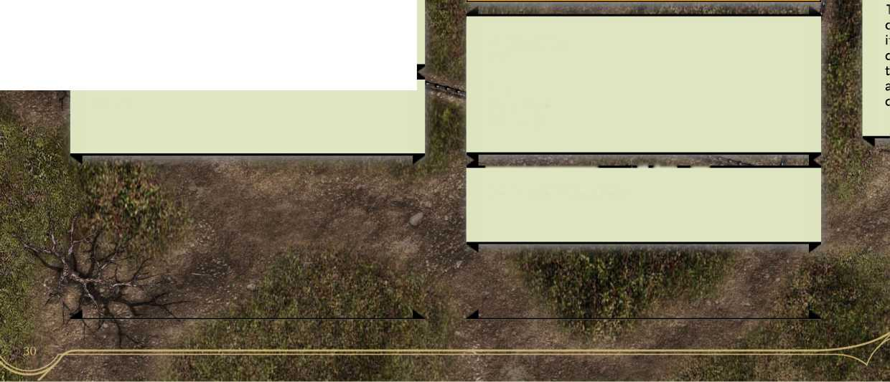**Unholy Curate**

Medium humanoid, any evil alignment

**Armor Class 1 5 (chain shirt)**

**Hit Points 28 (5d8+ 5)**

**Speed 30 ft.**

**Chill Touch. Ranged Spell Attack:** +4 to hit, range 120 ft, Two targets. Hit: 4 (1 d8) necrotic damage, on a hit, the target takes 1 d8 necrotic damage, and it can't regain hit points until the start of the curate's next turn. Until then, the hand clings to the target. If the curate hits an undead target, it also has disadvantage on attack rolls against the curate until the end of the curate's next turn.

**STR DEX CON INT WIS CHA**

**10 (+0) 14 (+2) 12 (+1) 11 (+0) 14 (+2) 12 (+1)**

**S№**

**I**

**Saving Throws Wis +4, Char +4 Skills Religion +3, History +3, Intimidation +4, Medicine +4**

**Senses passive Perception 12 Languages Common, Abyssal, Infernal Challenge 2 (450 XP)**

-

Not quite the lowest tier of the religious pyramid, unholy curates are doing better than acolytes and cultists (and the walking dead), but they still have a lot of room to advance. Life is competitive at the low levels, and rather than digging graves, unholy curates spend a fair amount of time undigging them.

**Spellcasting.** The curate is a 3rd-level spellcaster. Its spellcasting ability is Wisdom (spell save DC 12,

+4 to hit with spell attacks). The curate has the following cleric spells prepared:

**d**

**Cantrips (at will):** thaumaturgy, toll the dead, chill touch

**1st level (4 slots):** false life, ray of sickness, bane, inflict wounds, detect evil and good **2nd level (2 slots):** blindness/deafness, ray of enfeeblement, hold person, augury

—i s

**Touch of Death (1/day).** When the curate hits a creature with a melee attack, it deals an extra 11 points of necrotic damage.

**i**

**Actions**

b

**Scimitar. Melee Attack:** +4 to hit, reach 5 ft., one target. Hit: 5 (ld6 + 2) slashing damage.

Typical daily activities for unholy curates include keeping an eye out for good adventurers, terrorizing the local peasants, and practicing necromantic magics.

**Unholy Deacon**

Medium humanoid, any evil alignment

**Armor Class 19 (half plate, shield)**

**Hit Points 68 (12d8 + 24)**

**Speed 30 ft.**

**STR DEX CON INT WIS CHA**

**11 (+0) 14 (+2) 14 (+2) 10 (+0) 16 (+3) 12 (+1)**

Saving Throws Wis +7, Cha + 5 Skills Arcane +4, Deception + 5, Insight +7, Perception +7, Persuasion +5, Religion +4 Senses passive Perception 17 Languages Common, Abyssal, Infernal Challenge 9 (5,000 XP)

. ' '■* 11Nil-Ifr

**Inescapable Destruction.** Necrotic damage dealt by the deacon ignores resistance to necrotic damage.

**Thematic'NPCs**

The gigantic bartender nods as you walk in.

**Urban NPCs**

Aside from Commoner (CR 0) and the other statblocks, I was looking for some social-urban stats. Normal-ish people my party might come across. Some of these stats are outright silly, others are a bit more serious. Have a problem with murder-hobos? The real answer is to talk to them about it.

**rtHfÜT**

**ClacQ 14**

i oints 1Q5 (14d8 + 42)

For some fun, this section has a beefy bartender, a legendary beefy bartender, a dishonored veteran, and more. Have fun!

**Speed 40 ft. STR DEX**

**CON INT WIS CHA**

**Damage Resistances bludgeoning, piercing, and**

**slashing damage**

**Saving Throws Str +11, Con +10**

**Skills Athletics + 8, Insight +5, Intimidation +5,**

**Perception +5, Persuasion +5**

**Senses passive Perception 18**

**Languages Common, Thieves' Cant**

**Challenge 8 (3,900 XP)**

This section has both serious and silly stats. If you are one of those people who wants to avoid silly things like Camelot, here's a quick guide to which Urban NPCs are silly and which aren't.

**Bouncer.** **The bartender can move grappled targets at its normal speed.**

**Rager.** **The bartender adds +3 damage to Strength attacks, has advantage on Strength checks, and has resistance to bludgeoning, piercing, and slashing damage.**

**Beefy Bartender - very silly**

**Beggar - not that silly**

**Charmer - not that silly**

**Diplomat - very silly**

**Dishonored Veteran - serious**

**Gangster - serious**

**Hulking Slave - serious**

**Knowledgeable Elder - serious**

**Legendary Beefy Bartender - very, very silly**

**Normal Bartender - not that silly**

**Talented Child Pickpocket - not that silly**

**Town Cryer - very silly**

**Veteran Scammer - not that silly**

**Wee Con Artist - serious**

**Brute.** **The bartender does an one extra die of damage with attacks.**

**Reckless.** At the start of its turn, the bartender can gain advantage on all melee weapon attack rolls during that turn, but attack rolls against it have advantage until the start of its next turn.

**Beefy Bartender**

***Medium humanoid, any alignment***

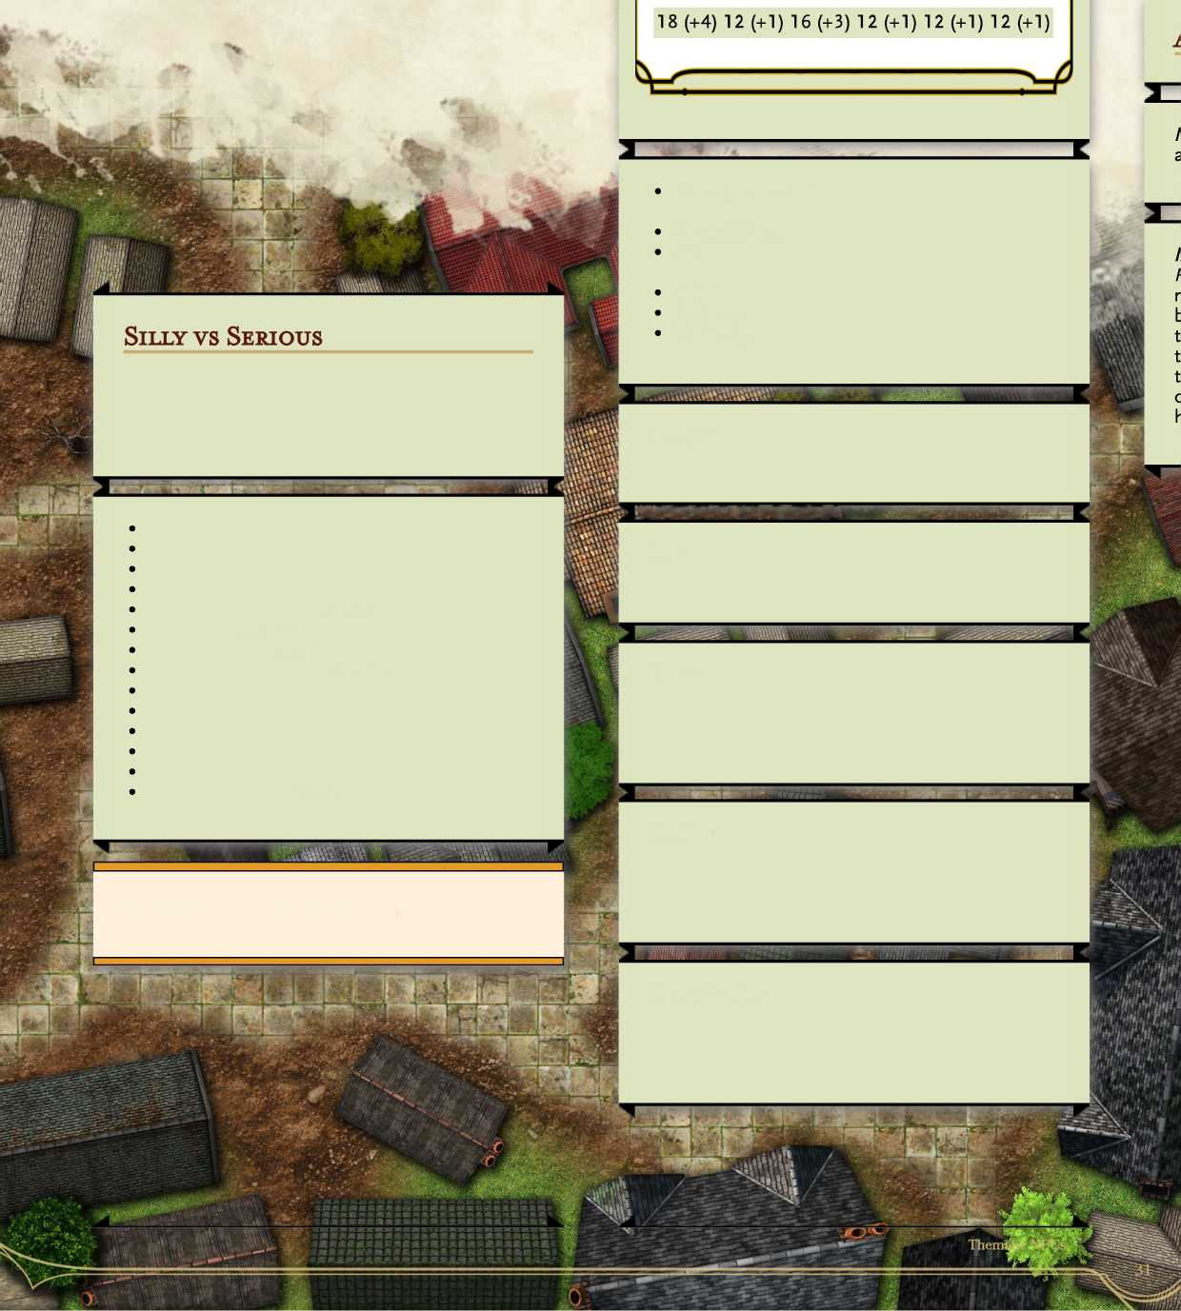**Tavern Brawler.** If the bartender hits a creature with an unarmed strike or improvised weapon, it can use a bonus action to attempt to grapple the target.

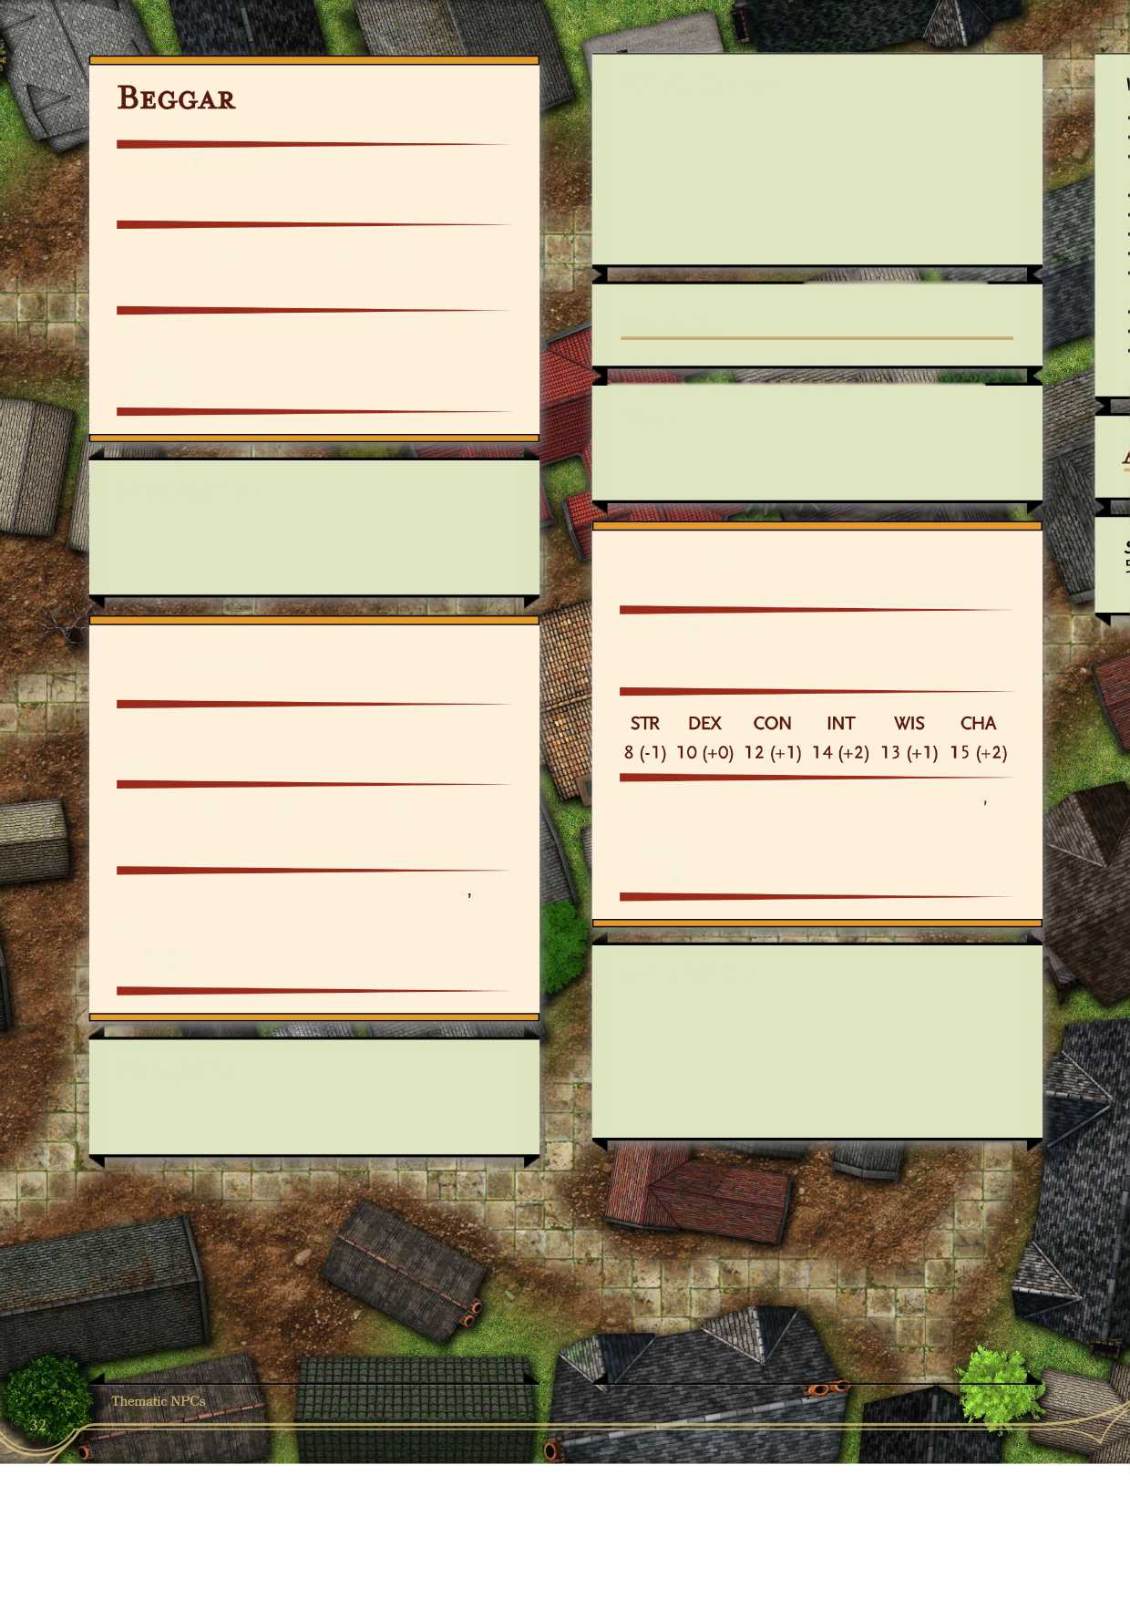

***Medium humanoid, neutral cautious***

|  |  |
| --- | --- |
| **Armor Class 10 (none) Hit Points 11 (2d8 +2) Speed 30 ft.** |  |
| **SIR DEX CON INT** | **WIS CHA** |
| **9 (-1) 10 (+0) 12 (+1) 9 (-1)** | **14 (+2) 9 (-1)** |
| **Skills Insight +6, Perception +6, Persuasion +1 Senses passive Perception 16 Languages Common, Thieves' Cant Challenge 0 (0 XP)** | |

**Actions**

**Distracting Presence.** As an action, the charmer talks to up to 5 creatures it can communicate with, they do not need to speak the same language. Each of the targets must make a DC 12 Wisdom (Insight) check or be distracted for ld4 turns. Distracted creatures have disadvantage on perception checks, and their passive perception is lowered by 5.

«

**Dagger. Melee or Ranged Weapon Attack:** +3 to hit, reach 5ft. or range 20/60 ft., one target. **Hit:** 3 (ld4+ 1) piercing damage.

**Watchful Observer.** If is the beggar is doing nothing else, it has advantage on perception rolls to observe its surroundings and insight rolls to watch the interactions of others.

**Diplomat**

***Medium humanoid, lawful arrogant***

**Armor Class 10 (none) Hit Points 11 (2d8 +2) Speed 30 ft.**

**Charmer**

***Medium humanoid, chaotic kinky***

|  |  |  |  |
| --- | --- | --- | --- |
| **Armor Class 11 (none)** |  |  |  |
| **Hit Points 1 3 (3d8) Speed 30 ft.** |  |  |  |
| **STR DEX CON** | **INT** | **WIS** | **CHA** |
| **9 (-1) 12 (+1) 11 (+0)** | **9(-l)** | **12 (+1)** | **14 (+2)** |

**Skills Deception +6, Insight +3, Perception +3 Persuasion +6, Sleight of Hand +3 Senses passive Perception 11 Languages Common + 2 others Challenge 1/8 (3,900 XP)**

**Skills Deception +4, History +4, Intimidation +6, Persuasion +4**

**Senses passive Perception 11 Languages Common + 3 others Challenge 0 (0 XP)**

**Cunning Action.** **On each of its turns, the charmer can use a bonus action to take the Dash, Disengage, or Hide action.**

**Stories of the Past** **Characters listening to the diplomat talk about politics for more than 1 minute must make a DC 1 2 Save (Player's choice but must explain) or zone out for the rest of the conversation. While zoned out, choose one of the following to happen to a random zoned out character.**

**Dishonored Veteran**

Humanoid, any alignment

|  |  |  |
| --- | --- | --- |
| **Armor Class 1 3 (chain shirt)** |  |  |
| **Hit Points 120 (16d8 +48) Speed 40 ft.** |  |  |
| **STR DEX CON INT** | **WIS** | **CHA** |
| **18 (+4) 11 (+0) 16 (+3) 10 (+0)** | **14 (+2)** | **9(-l)** |

**Saving Throws Con +6, Str +8**

**Skills Athletics +8, Insight +6, Perception +6**

**Senses passive Perception 16**

**Languages Common**

**Challenge 7 (2,900 XP)**

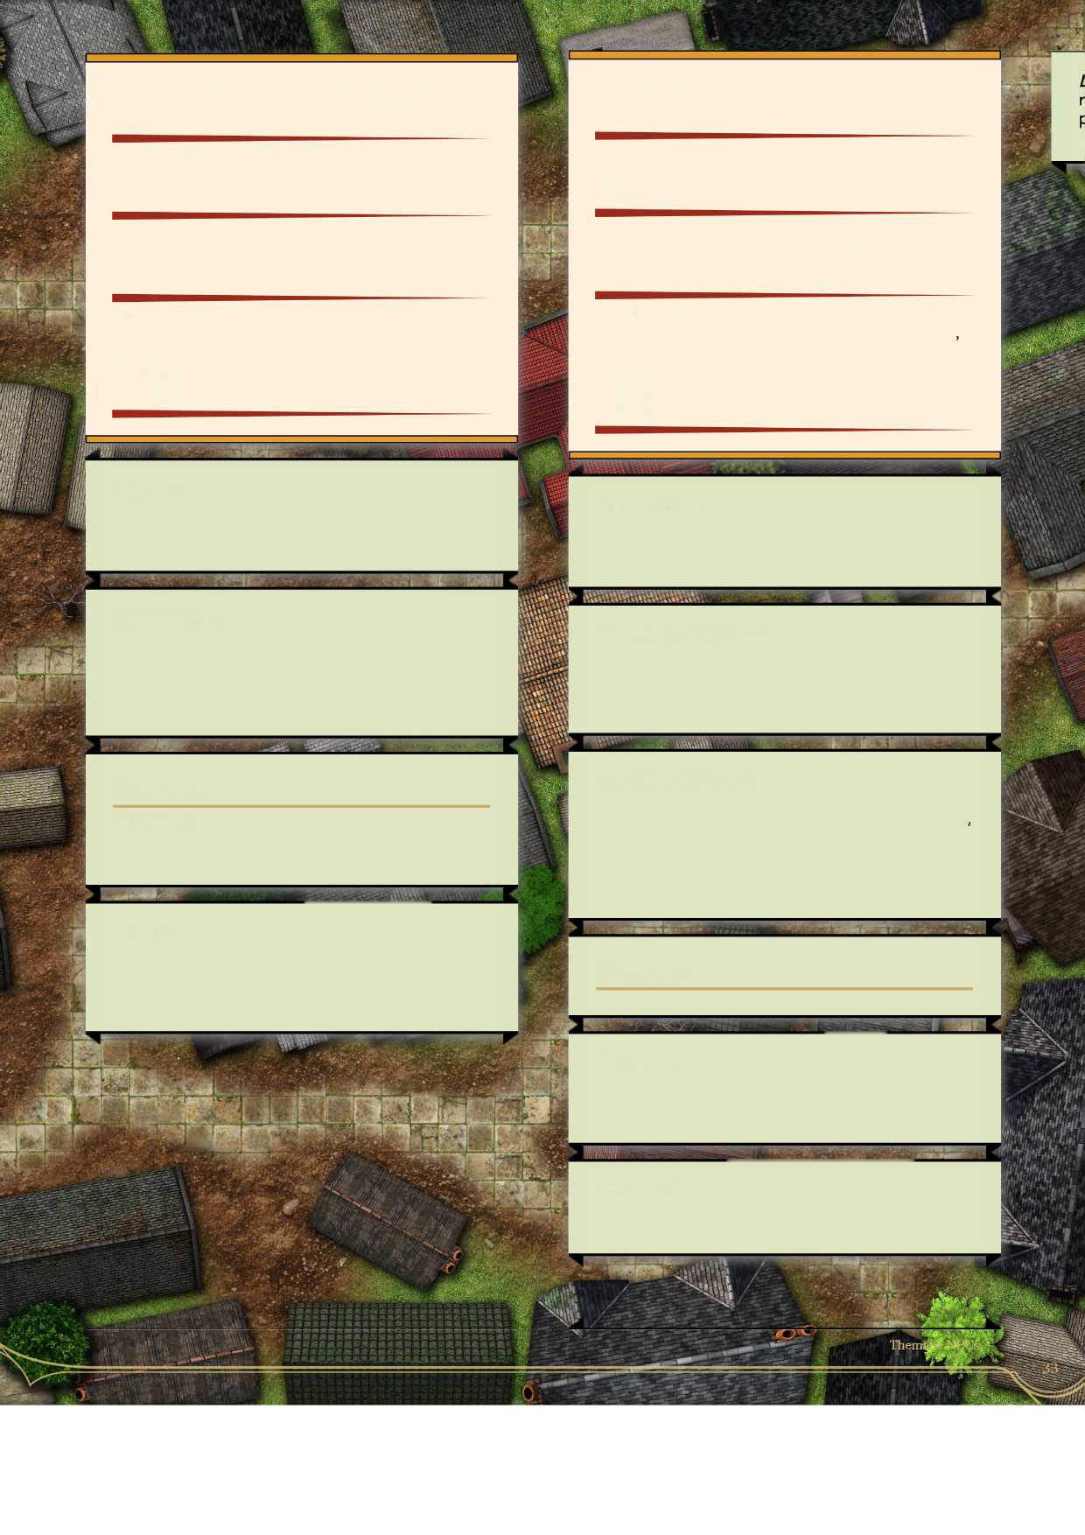

**Gangster**

Medium humanoid, any alignment

|  |  |  |
| --- | --- | --- |
| **Armor Class 14 (studded leather)** |  |  |
| **Hit Points 65 (10d8 + 20) Speed 30 ft.** |  |  |
| **STR DEX CON INT** | **WIS** | **CHA** |
| **16 (+3) 14 (+2) 14 (+2) 9 (-1)** | **10 (+0)** | **14 (+2)** |

**Saving Throws Dex +5, Int +2 Skills Athletics +6, Deception +5, Intimidation +5 Perception +3, Stealth +5 Senses passive Perception 1 3 Languages Common, Thieves' Cant Challenge 3 (700 XP)**

**Aggressive:** As a bonus action, the veteran can move up to its speed toward a hostile creature that it can see.

**Cunning Action.** On each of its turns, the gangster can use a bonus action to take the Dash, Disengage, or Hide action.

**Wounded Fury.** While it has 1/2 of its hit points maximum or fewer, the veteran has advantage on melee attack rolls. In addition, it deals an extra 7 (2d6) damage to any target it hits with a melee attack and is immune to charm and fear effects.

**Menacing Strike (1/turn).** When the gangster hits a creature with an attack, the creature must make a DC 14 Wisdom save or be frightened until the end of the gangster's next turn.

**Actions**

**Multiattack.** The veteran makes three weapon attacks.

**Sneak Attack (1/Turn).** The gangster deals an extra 10 (3d6) damage when it hits a target with a weapon attack and has advantage on the attack roll, or when the target is within 5 feet of an ally of the gangster that isn't incapacitated and the gangster doesn't have disadvantage on the attack roll.

**Battleaxe. Melee Weapon Attack:** +8 to hit, reach 5ft, one target. **Hit** 8 (ld8 + 4) slashing damage, or 9 (1 dl 0 + 4) slashing damage if used with two hands to make a melee attack.

**Actions**

**Multiattack.** The gangster makes two shortsword attacks and one melee dagger attack or throws two daggers.

|  |  |
| --- | --- |
| **KV._** |  |
| **tfflfc 1 'V** |  |

**Shortsword. Melee Weapon Attack: +6** to hit, reach 5ft., one target. **Hit 6** (ld6 + 3) piercing damage.

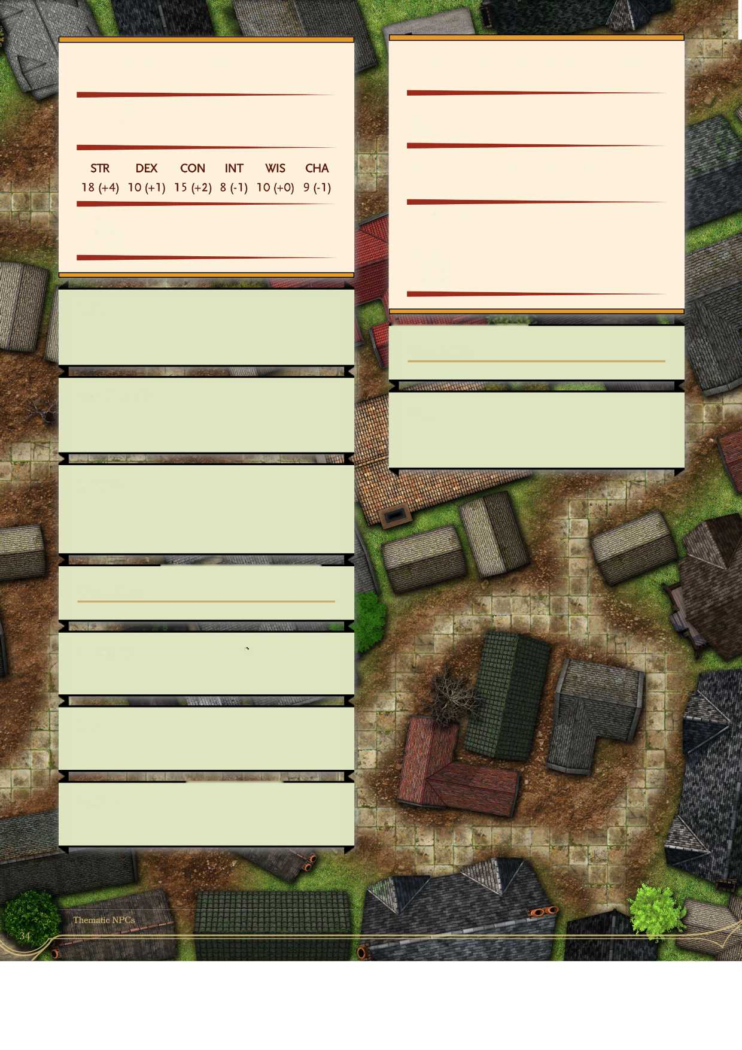**Hulking Slave**

***Medium or large humanoid, any alignment***

**Knowledgeable Elder**

***Medium humanoid, any alignment***

|  |  |  |  |
| --- | --- | --- | --- |
| **Armor Class 10** |  |  |  |
| **Hit Points 9 (2d8) Speed 30 ft.** |  |  |  |
| **STR DEX CON** | **INT** | **WIS** | **CHA** |
| **9 (-1) 10 (+0) 10 (+0)** | **16 (+3)** | **17 (+3)** | **15 (+2)** |

**Armor Class 10**

**Hit Points 39 (6d8+ 12)**

**Speed 30 ft.**

**Senses passive Perception 10 Languages Common Challenge 1 (200 XP)**

**Saving Throws Wis + 5**

**Skills Arcana +5, Deception +4, History +5, Insight +7, Intimidation +4, Perception +7, Religion +5 Senses passive Perception 1 7 Languages Common + 3 others Challenge 0 (0 XP)**

**Brute.** A melee weapon deals one extra die of its damage when the slave hits with it (included in the attack).

**m**

**Actions**

**Powerful Build. If medium sized, the slave counts as one size larger when determining carrying capacity and the weight they can push, drag, or lift.**

**Dagger. Melee or Ranged Weapon Attack: +2 to hit, reach 5 ft. or range 20/60 ft, one target. Hit: 2 (ld4) piercing damage.**

**Reckless.** At the start of its turn, the slave can gain advantage on all melee weapon attack rolls during that turn, but attack rolls against it have advantage until the start of its next turn.

a

**Actions**

**Multiattack** The slave makes two fist attacks per turn.

**Fist Melee Weapon Attack: +4** to hit, reach 5 ft, one target. **Hit** 9 (2d4 + 4) bludgeoning damage.

**Boulder.** Range Weapon Attack:* +4 to hit, range 20/40 ft, 1 3 (2d8 + 4) bludgeoning damage.

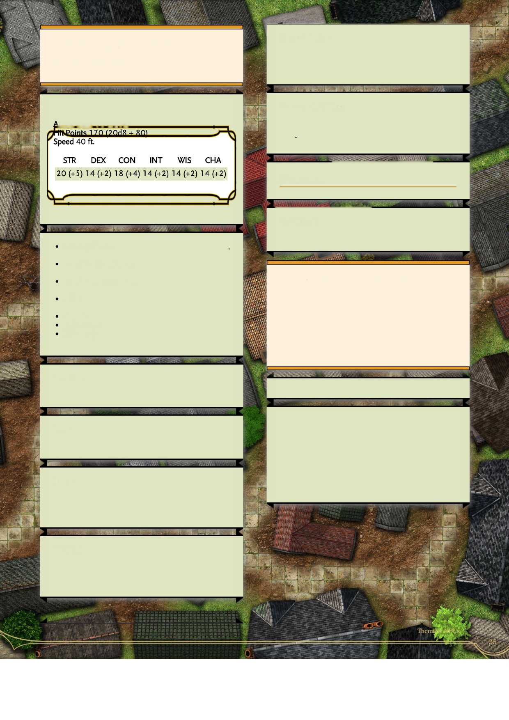**Bouncer.** The bartender can move grappled targets at its normal speed.

**Legendary Beefy Bartender**

***Medium or large humanoid, any alignment***

**Tavern Brawler. If the bartender hits a creature with an unarmed strike or improvised weapon, it can use a bonus action to attempt to grapple the target.**

***The gigantic bartender nods as you walk in.***

>rmpr Class 16 (nonfi)

**Unarmored Defense. The bartender's armor class equals 10 + its Dexterity modifier + its Constitution modifier if it not wearing any armor or using a shield.**

**Actions**

**Multiattack. The bartender makes three weapon attacks.**

**Saving Throws Str +11, Dex +8, Con +10, Int +8: Wis+8, Char+8**

**Damage Resistances bludgeoning, piercing, and slashing damage**

**Condition Immunities charmed, stunned, paralyzed, poisoned**

**Skills Athletics +11, Insight +8, Intimidation +8, Perception +8, Persuasion +8 Senses passive Perception 18 Languages Common, Thieves' Cant Challenge 1 5 (1 3,000 XP)**

**Improvised Weapon or Unarmed Strike. Melee or Ranged Weapon Attack: + 11 to hit, reach 5 ft. or ranged 20/60 feet., one target. Hit: 16 (3d4 + 9) bludgeoning damage. If the bartender moves more than 10 feet in a straight line before attacking a target and then hits, it then automatically shoves the creature 10 feet away in the opposite direction or deals an additional 5 points of damage on the hit.**

**Brute. The bartender does an two extra die of damage with attacks.**

**Rager. The bartender adds +4 damage to Strength attacks, has advantage on Strength checks, and has resistance to bludgeoning, piercing, and slashing damage.**

**Towering over the party, this massive bartender is a hulking beast of a person. Rumor has it, legendary beefy bartender was once have been a legendary barbarian in their day. Now retired to run an inn or bar, the LBB is happy serving drinks, listening to bards, and cracking the heads of uppity adventurers who come into their establishment and start trouble.**

**Reckless.** At the start of its turn, the bartender can gain advantage on all melee weapon attack rolls during that turn, but attack rolls against it have advantage until the start of its next turn.

**Normal Bartender**

**Actions**

**Armor Class 10 (none) Hit Points 13 (3d8) Speed 30 ft.**

***Medium humanoid, true neutral***

**Rock. Ranged Weapon Attack:** +0 to hit, reach 5ft. or range 10/20 ft., one target. **Hit:** 1 (1 d2) bludgeoning damage.

**Skills Acrobatics +4, Insight +4, Perception +3 Persuasion +3**

**Senses passive Perception 1 3 Languages Common + 2 others Challenge 0 (0 XP)**

**Town Cryer**

***Medium humanoid, lawful sad***

|  |  |
| --- | --- |
| **Armor Class 9 (none) Hit Points 3 (ld8 -1) Speed 20 ft.** |  |
| **STR DEX CON INT WIS** | **CHA** |
| **9 (-1) 9(-l) 9 (-1) 9 (-1) 9 (-1)** | **12 (+1)** |
| **Skills Persuasion +3 Senses passive Perception 10 Languages Common, Thieves' Cant Challenge 0 (0 XP)** |  |

**Run for cover. The bartender has advantage on initiative. The bartender can use a bonus action to use the Dash, Disengage, or Dodge action, all the while shouting "GUARDS, GUARDS, GUARDS!". The bartender can shout the word "GUARDS!" while they take any bonus action, action, or move.**

*mm*

***Small humanoid, chaotic desperate***

|  |  |  |  |
| --- | --- | --- | --- |
| **Armor Class 12 (none) Hit Points 7 (2d8 -2) Speed 2 5 ft.** |  |  |  |
| **STR DEX CON** | **INT** | **WIS** | **CHA** |
| **6 (-2) 15 (+2) 8 (-1)** | **7 (-2)** | **11 (+0)** | **12 (+1)** |

**Skills Perception +2, Persuasion +3, Sleight of Hand +6, Stealth +6,**

**Senses passive Perception 12 Languages Common, Theives1 Cant Challenge 0 (0 XP)**

**Reward for the Empathie. The cryer stops crying and feels better. They relay information about rumors of a magical item in an abandoned place in town if the party feels they have the mettle to go retrieve it.**

**Incessantly Crying. Anyone who comes within 5 feet of the cryer must make a DC 11 Wisdom save or lose 1 d4 temporary hit points as the alligator tears of the cryer eat through those HP.**

**Braving the Tears. If party members talk to the cryer, they must each make a DC 11 Constitution check or they take a point of exhaustion as the cryer tells them their woe tale.**

**Cunning Action.** On each of its turns, the pickpocket can use a bonus action to take the Dash, Disengage, or Hide action.

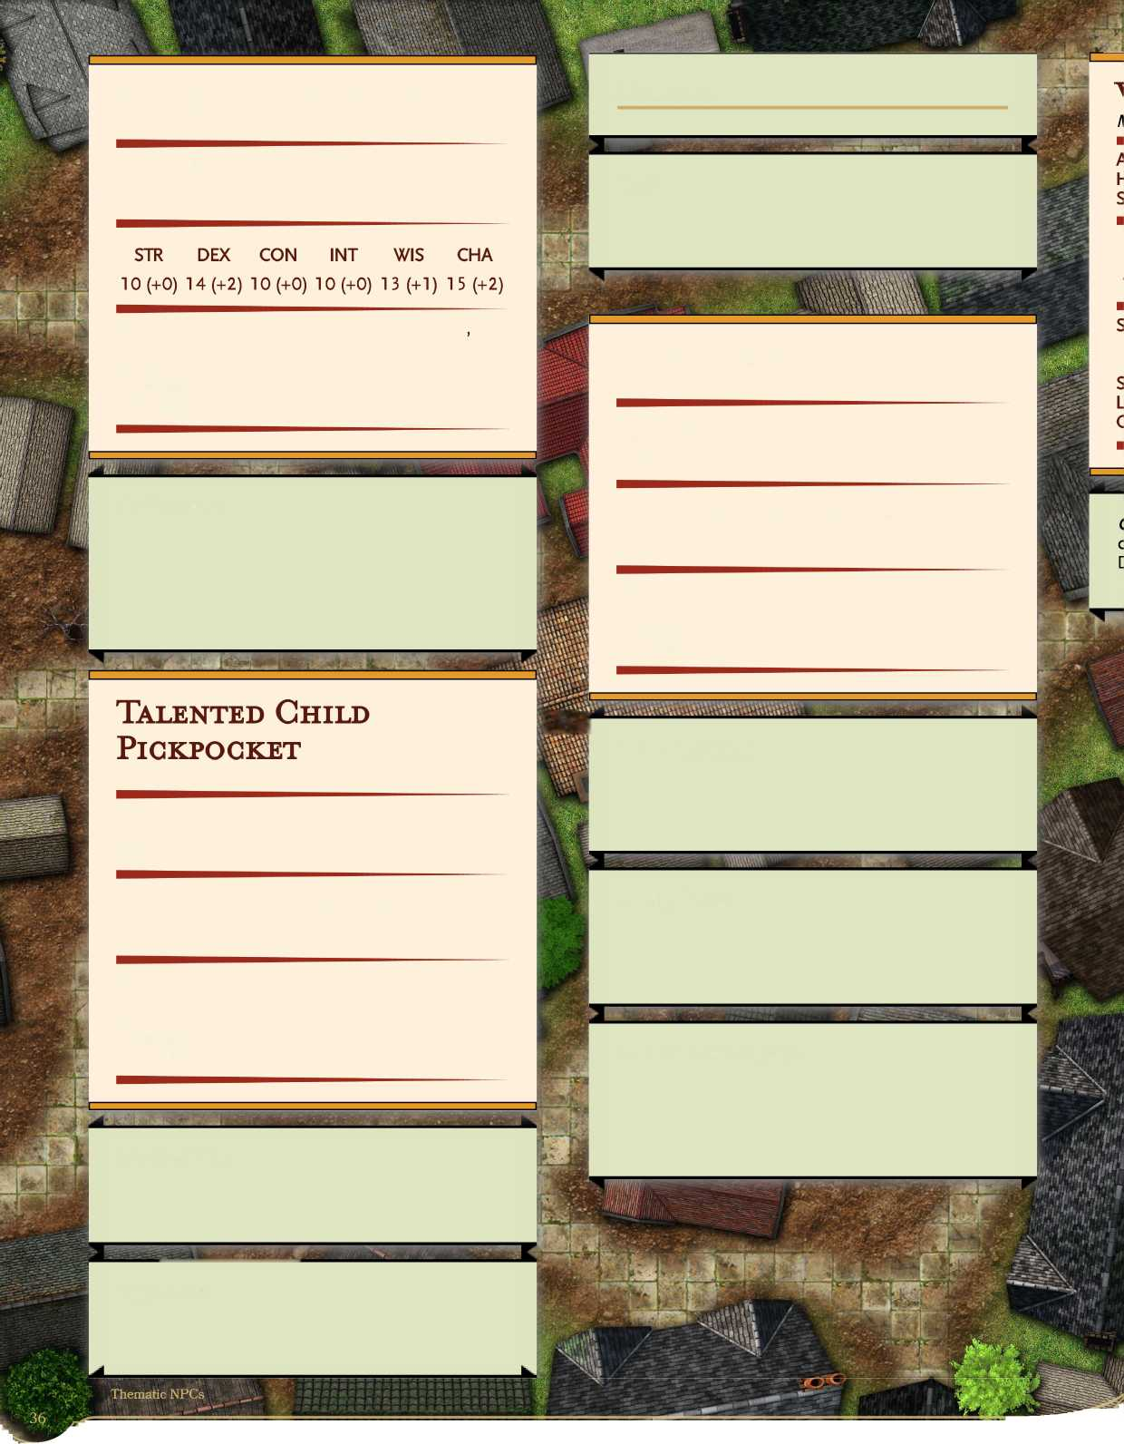**Opportunist** The pickpocket has advantage on sleight of hand and stealth checks on targets who aren't paying attention to it.

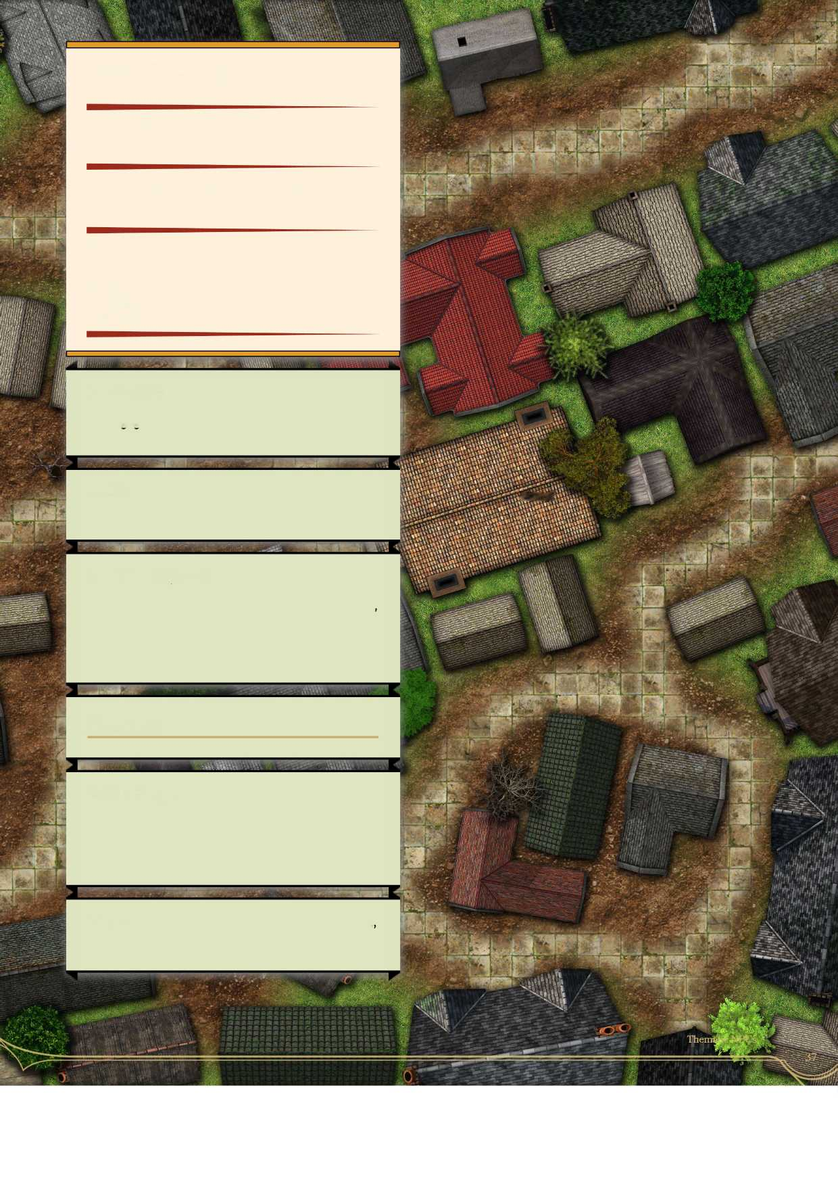

**Wee Gon Artist**

***Small humanoid, any alignment***

|  |  |  |  |
| --- | --- | --- | --- |
| **Armor Class 12** |  |  |  |
| **Hit Points 31 (7d8) Speed 30 ft.** |  |  |  |
| **STR DEX CON** | **INT** | **WIS** | **CHA** |
| **8 (-1) 15 (+2) 10 (+0)** | **14 (+2)** | **12 (+1)** | **17 (+3)** |

|  |  |
| --- | --- |
|  |  |
| **tikTd r'**  **, * .^1, . fofcX ; . jgud** |  |
|  |

|  |  |  |
| --- | --- | --- |
|  | **fell** |  |
| HJS Si |  |  |
| *| V V T J | |  | |

**Skills Acrobatics +6, Deception +7, Insight +3, Perception +3, Performance +5, Persuasion +7, Sleight of Hand +6 Senses passive Perception 1 3 Languages Common and Undercommon + 1 other Challenge 1/2 (100XP)**

**Cunning Action.** On each of its turns, the con artist can use a bonus action to take the Dash, Disengage, or Hide action.

**Nimble.** The con artist can move through the space of any enemy that is medium or larger.

**Sneak Attack (\/Turn).** The con artist deals an extra 10 (3d6) damage when it hits a target with a weapon attack and has advantage on the attack roll, or when the target is within 5 feet of an ally of the con artist that isn't incapacitated and the wee con artist doesn't have disadvantage on the attack roll.

**Actions**

**Sand in the Eyes. Melee Weapon Attack:** +4 to hit, reach 5ft., one target. **Hit** 2 (ld4) piercing damage and the target must make a DC 12 Constitution save or be blinded until they spend an action rubbing their eyes.

**Dagger. Melee Weapon Attack:** +4 to hit, reach 5ft. one target. **Hit** 4 (ld4 + 2) piercing damage.

**Ray of Frost Range Spell Attack:** +8 to hit, range 60 ft, one target. Hit: 9 (2d8) cold damage.

**Wilderness NPGs**

This section is NPCs for wilderness encounters that do not involve giants, hags, dire wolves, etc. The following are various wilderness NPCs to be encountered in camps, hamlets, very small villages, or even in cabins in the woods. The forest witch and witch doctor specifically are unique spellcasting classes, as their spells do not come from a specific list. Instead, they have spells based upon specific schools of magic.

[**Actions ]**](#bookmark27)

/1

1 L

***p***

Shillelagh: Melee Weapon Attack: **+8 to hit, reach h**

5ft., one target. Hit: 8 (ld8 +4) bludgeoning **S**

damage. **■**

a:

E

**to-l V**

**Forest Witch**

***Medium humanoid, any alignment***

**Armor Class 12 (none) Hit Points 58 (9d8+ 18) Speed 30 ft.**

**STR DEX CON INT WIS CHA**

**8 (-1) 14 (+2) 14 (+2) 18 (+4) 12 (+1) 10 (+10)**

Saving Throws Int +8, Wis +5

Skills Medicine +5, Nature +9, Perception +5

Senses passive Perception 1 5

Languages Common, Sylvan, Abyssal, Primordial

Challenge 4 (1,100 XP)

**Spellcasting.** The witch is a 9th-level spellcaster.

The witch's spellcasting ability is Intelligence (spell save DC 1 6, +8 to hit with spell attacks). The witch knows the following spells:

**Cantrips (at will): *druidcraft, shillelagh, ray of frost, dancing lights***

**1st level (4 slots): *cure wounds, detect magic, identify, jump***

**2nd level (3 slots): *see invisibility, detect thoughts* 3rd level (3 slots): *fly, lightning bolt, mass healing word***

**4th level (3 slots): *giant Insect, polymorph* 5 th level (1 slots): *contact Other Plane, reincarnate***

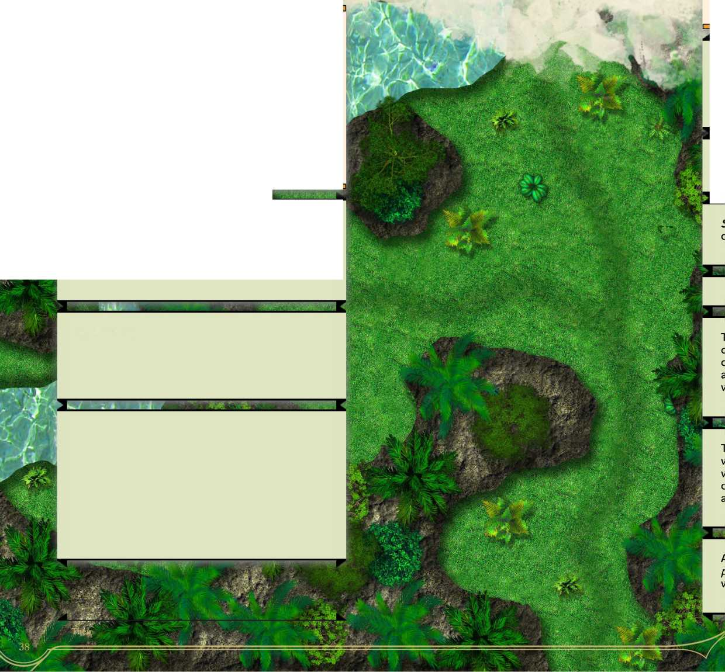**taticNPCs**



**3**

**iiS**

**Outlaw**

***Medium humanoid, any alignment***

**Armor Class 16 (studded leather) Hit Points 82 (lld8 + 33)**

**Speed 40 ft.**

**STR DEX CON INT WIS CHA**

**10 (+0) 18 (+4) 14 (+3) 9 (-1) 14 (+2) 12 (+1)**

**Saving Throws Str + 3, Dex +5 Skills Acrobatics +8, Animal Handling +6, Deception +5, Perception +6, Stealth +8, Survival +5**

**Senses passive Perception 16 Languages Common Challenge 7 (2,900 XP)**

**Multiattack.** The outlaw makes three shortsword attacks or two longbow attacks.

**Shortsword. Melee Weapon Attack:** +8 to hit, reach 5ft., one target. **Hit:** 7 (ld6 + 4) piercing damage, and the target must succeed on a DC 11 Constitution saving throw, taking 10 (3d6) poison damage on a failed save, or half as much damage on a successful one.

**Long Bow. Range Weapon Attack:** +8 to hit, range 80/320 ft., one target. **Hit:** 8 (ld8 +4) piercing damage, and the target must succeed on a DC 11 Constitution saving throw, taking 10 (3d6) poison damage on a failed save, or half as much damage on a successful one.

**Combat Maneuvers.** Once per turn, the outlaw can use one of the following effects:

**Parry. When another creature damages the outlaw, the outlaw can us its reaction to reduce the damage by ldl 2+4.**

* Trip Attack: A larger or smaller creature hit by one of the outlaw's attacks must make a DC 1 5 Strength save or be knocked prone.
* Menacing Attack: When the outlaw hits a creature with an attack, the creature must make a DC 1 5 Wisdom save or be frightened until the end of the outlaw's next turn.
* Disarming Attack: When the outlaw hits a creature with a weapon attack, the target must make a DC 1 5 Strength check or drop a weapon of the outlaw's choice which lands at the creature's feet.

**Reaction**

**Cunning Action.** On each of its turns, the outlaw can use a bonus action to take the Dash, Disengage, or Hide action.

**Sneak Attack (1/Turn).** The outlaw deals an extra 10 (3d6) damage when it hits a target with a weapon attack and has advantage on the attack roll, when the target is within 5 feet of an ally of the outlaw that isn't incapacitated and the outlaw doesn't have disadvantage on the attack roll, or if no creature other than the target is within 5 feet of the outlaw.

The outlaw isn't in the wilderness by choice. The outlaw is on the run either on their own or with a small group of allies who may or may not know their true identity. If confronted, the outlaw will not hesitate to run if things get tough, after all that's what they are doing in the wilderness in the first place.

The outlaw's combat maneuvers, combined with their cunning action, can make them a difficult foe to take down although their real advantage lay in their damage output. The outlaw is most likely to try and take out the weakest foe possible, then flee if they don't have backup.

**Actions**

Outlaws are commonly in the company of Brigands (CR 1/8), Brigand Captains (CR 2) and other low­lifes who take to the woods.

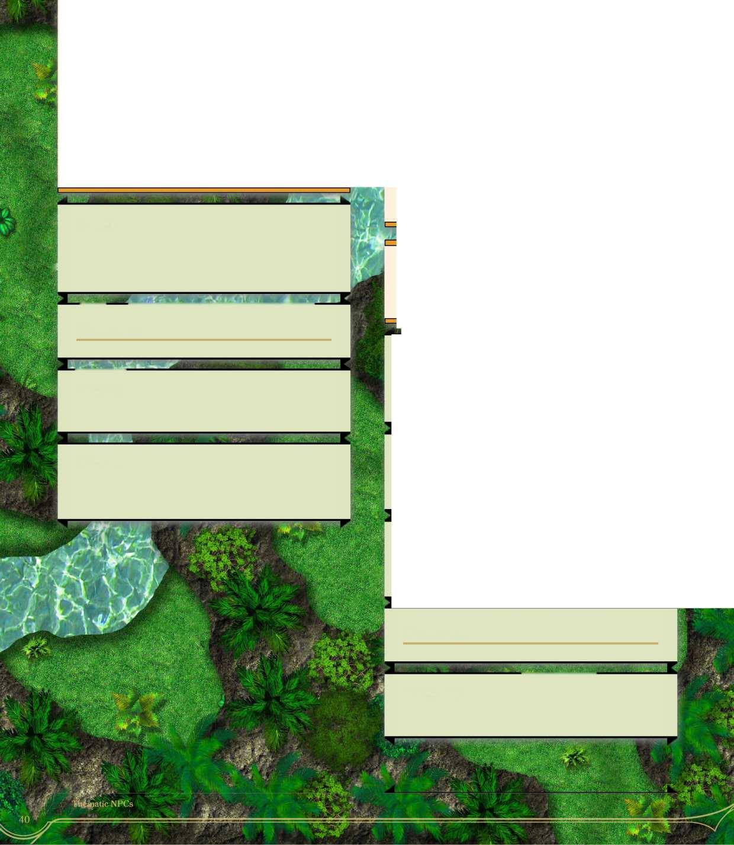

**Skills Animal Handling +3, Nature +2, Perception +3, Stealth +4, Survival +3 Senses passive Perception 1 3 Languages Common Challenge 1/8 (3,900 XP)**

**Trapper**

***Medium humanoid, any alignment***

**Armor Class 1 3 (leather armor)**

**Hit Points 16 (3d8 +3)**

**Speed 30 ft.**

**—**

**STR DEX CON INT WIS CHA**

13 (+1) 15 (+2) 12 (+1) 10 (+0) 13 (+1) 10 (+0)

**Veteran Wilderness Guide**

***Medium humanoid, any alignment***

**Armor Class 1 5 (leather armor) Hit Points 104 (16d8 + 32) Speed 30 ft.**

**STR DEX CON INT WIS CHA**

**12 (+1) 18 (+4) 14 (+2) 10 (+0) 16 (+3) 8 (-1)**

**Saving Throws Str +5, Dex +8 Skills Animal Handling +7, Athletics +5, Nature +4, Perception +7, Survival +7 Senses passive Perception 1 7 Languages Common + 2 others Challenge 6 (2,300 XP)**

**I—** tn

**Trapper.** Given 1 minute and supplies, the trapper can create a trap large enough to restrain a large or smaller creature. The DC to spot and escape the **^** trap is 11.

*

**Actions**

**—**

**Eagle Eye.** The guide has advantage on Perception checks (sight), and does not suffer penalties for shooting at targets with 1 /2 or 3/4 cover.

**Hand Axe. Melee Weapon Attack: +3** to hit, reach 5ft., one target. **Hit: 4** (ld6 +1) slashing damage.

**Short Bow. Range Weapon Attack: +4** to hit, range 80/320 ft, one target. **Hit:** 5 (ld6 +2) piercing damage.

**Natural Healer (3/day).** Using herbs and other natural components, the guide can cast **cure wounds at** 1st level, Wisdom is its spellcasting ability for the purpose of this spell.

**Stealthy Aura (3/day).** For the next hour, up to 10 creatures within 30 feet of the guide gain a +10 to their stealth checks.

**Wilderness Guide.** The guide ignores difficult terrain movement penalties and cannot get lost in the wild.

**Actions**

;

**Multiatttack.** The guide makes three weapon attacks.

**Wild ling**

***Medium humanoid, any alignment***

**Armor Class 1 3 (hide)**

**Hit Points 58 (9d8+ 18)**

**Speed 40 ft., climb 40 ft., swim 40 ft.**

**STR DEX CON INT WIS CHA**

**16 (+3) 12 (+1) 14 (+2) 8 (-1) 14 (+2) 8 (-1)**

**Roped, BarbedJavelins. Ranged Weapon Attack:** +6 to hit, range 20/60 ft, one target. Hit: 6 (ld6 +3) piercing damage. Once hit, the creature then has a javelin sticking out of it, it must use an action to remove the barbed using a DC 11 Wisdom (Medicine) check, taking ld4 piercing damage on a fail. Alternatively, it can strike the rope (AC 14, hit points 2). The creature cannot move beyond 60 feet from the wildling until it does, but it still has the javelin embedded in it.

* Saving Throws Con +7
* Skills Athletics +6, Perception + 5, Stealth +4, Survival +5
* Senses passive Perception 1 5
* Languages Unfamiliar dialect of Common
* Challenge 2 (450 XP)

**Aggressive.** The wildling can us a bonus action to move up to its movement towards an enemy.

**Witch Doctor**

Medium humanoid, any alignment

|  |  |  |  |
| --- | --- | --- | --- |
| **Armor Class 13** |  |  |  |
| **Hit Points 91 (14d8 + 28) Speed 30 ft.** |  |  |  |
| **STR DEX CON** | **INT** | **WIS** | **CHA** |
| **10 (+0) 16 (+3) 14 (+2)** | **18 (+0)** | **12 (+1)** | **8 (■!)** |

**Brute.** The wildling does an one extra die of damage with melee weapon attacks.

Saving Throws Int +9, Wis +6 Skills Medicine +6 Senses passive Perception 16 Languages Common, Abyssal, Primordial Challenge 6 (2,300 XP)

**Reel-em In.** The wildling can use its bonus action and pull a creature previously hit by a javelin whose line it can reach, 10 feet closer to it. The creature can resist by making a contested Strength (Athletics) check.

**Spellcasting.** The doctor is a 14th-level spellcaster. Its spellcasting ability is Intelligence (spell save DC 17, +9 to hit with spell attacks). The doctor knows the following spells:

**I**

**Actions**

**Multiattack. The wildling makes three claw glove attacks or two javelin attacks.**

**Claw gloves. Melee Weapon Attack: +6 to hit, reach 5 ft, one target. Hit: 8 (2d4 +3) slashing damage.**

**Cantrips (at will): *chill touch, minor illusion, spare the dying, toll the dead***

**1st level (4 slots): *ray of sickness, inflict wounds, silent image, disguise self, cause fear* 2nd level (3 slots): *blur, mirror image, blindness/deafness***

**3rd level (3 slots): *animate dead, fear, vampiric touch***

**4th level (3 slots): phantasmal killer, blight 5th level (2 slots): dream, raise dead 6th level (1 slot): magic jar, create undead 7th level (1 slot): simulacrum**

**Actions**

^rmeoi

**Speed 30 ft.**

|  |  |
| --- | --- |
| Cantrips (at will): 1st level (4 slots): 2nd level (3 slots): **3rd** level **(3** slots): 4th level (3 slots): 5th level **(3** slots): 6th level (2 slot): 7th level (2 slot): 8th level (1 slot): 9th level (1 slot): |  |
| i | c |
| **Actions** | |
|  |  |
| 3 | r |
| **X. Melee or Ranged Spell Attack:** +X to hit, reach X ft. or range X/X ft, one target. Hit: X (XdX) X damage. | |

**^ r**

**Appendix A: NPG Template**

l 1

**Spellcasting NPG**

***Medium humanoid\ any alignment***

toints X (Xri» t X)

STR DEX CON INT WIS CHA

10 (+0) 10 (+0) 10 (+0) 10 (+0) 10 (+0) 10 (+0)

***1 L***

* Saving Throws Save +X
* Skills Skill +X
* Senses passive Perception X
* Languages Common
* Challenge X (X XP)

**a e**

**Innate Spellcasting.** The X's innate spellcasting ability is Intelligence. The X can innately cast the following spells (spell save DC X), requiring no material components:

i t

At will:

Cantrips:

3/day each:

2/day each:

1 /day each: **

3 g

**Spellcasting.** The X is a Xth-level spellcaster. Its spellcasting ability is Wisdom (spell save DC X, +X to hit with spell attacks). The X has the following cleric spells prepared:

^ **V**

**Appendix B: Legendary Actions**

I did not build out legendary actions for the higher-level NPCs in this supplement, but I thought I'd address the issue here. From looking at the MM and other sources, legendary actions aren't given out automatically because a creature had a high CR. For example, the Balor (CR 19) and Death Knight (CR 17) from the MM don't have legendary actions meanwhile the Vampire (CR 13) does. Therefore, it makes sense that legendary actions are instead given to creatures meant to feel like main antagonists, like the real bad guys. For more information see page 11 of the MM.

Instead of making legendary actions for these NPCs, I decided instead to compile some examples. If you'd like one of these statblocks to be a more threatening antagonist, build out some legendary actions for them.

**What Legendary Actions should** NPCs **GET?**

In order to get a good handle on legendary actions, I looked through the MM and VGtM to see what legendary actions were given to all of the creatures in there. I made a list summarizing what types of legendary actions those get. Standard creatures with legendary actions get 3.

"The creature can take 3 legendary actions, choosing from the options below. Only one legendary action option can be used at a time and only at the end of another creature's turn. The creature regains spent legendary actions at the start of its turn."

Here are some examples:

* Make a regular attack (1 action)
* Move up to 1/2 its speed (1 action)
* Move up to its speed (1 action)
* Grapple or shove a creature (1 action)
* Make a powerful attack, such as a bite (2 actions)
* Make a skill check (1 action)
* Cast a Cantrip (1 action)
* Cast a spell (3 actions)
* Cast a 1st level spell (1 action)
* Cast a 2nd level spell (2 actions)
* Cast a 3rd level spell (3 actions)
* Use a uniue ability, like a minor buff (1 action)
* Use a unique ability, usually an attack with a minor side effect or a major buff (2 actions)
* Use a unique ability, usually a powerful debuff of some kind or a self-heal (3 actions)

For the NPCs in this supplement, some other possible legendary actions include

* Move up to its speed or 1/2 its speed without provoking attacks of opportunity (1 action)
* Drink a healing potion (2 actions)
* Take the Dodge action (2 actions)
* Use the Help action (1 action)
* Drink a potion (2 actions)

**Adding Legendary Resistance**

Adding legendary resistance to a creature has the following effect on CR:

"Each per-day use of this trait increases the monster's effective hit points based on the expected challenge rating: 1- 4, 10 hp; 5-10, 20 hp; 11 or higher, 30 hp."

Based on this, adding 2-3 uses of legendary resistance to a creature can be expected to increase its CR by up to 1.